**Data Engineering End-To-End project**

**Reference** - <https://www.youtube.com/watch?v=pMqnvXgPKlI&t=1963s>

( source - <https://www.youtube.com/@learnbydoingit>)

**Disclaimer** : I have followed the video and have been successful in creating the end-to-end Data Engineering project on Pizza-Sales data. I have come across some bottlenecks while implementing the same and hence added references in my document how I resolved the same. I have taken help from other you tube channels and internet resources for the purpose. Hope it helps others anyway.

Thanks to all for putting out these valuable resources online so anyone can learn and implement.

**Tools learnt** –

1. SQL server migration

2. Azure Data Factory

3. Azure Data Lake Storage Gen2

4. Azure Databricks

5. PYSPARK

6. SPARK SQL

7. Microsoft Power BI

**Installation required** –

1. SQL Server Management Studio 19
2. Microsoft Integration Runtime
3. Azure portal (web application, only open with outlook mail with card details for free trial. 2 rupees will be debited for validating credential then MS will credit the same to user. Mark the free trial subscription period. Below is a snapshot to know when your trial ends)

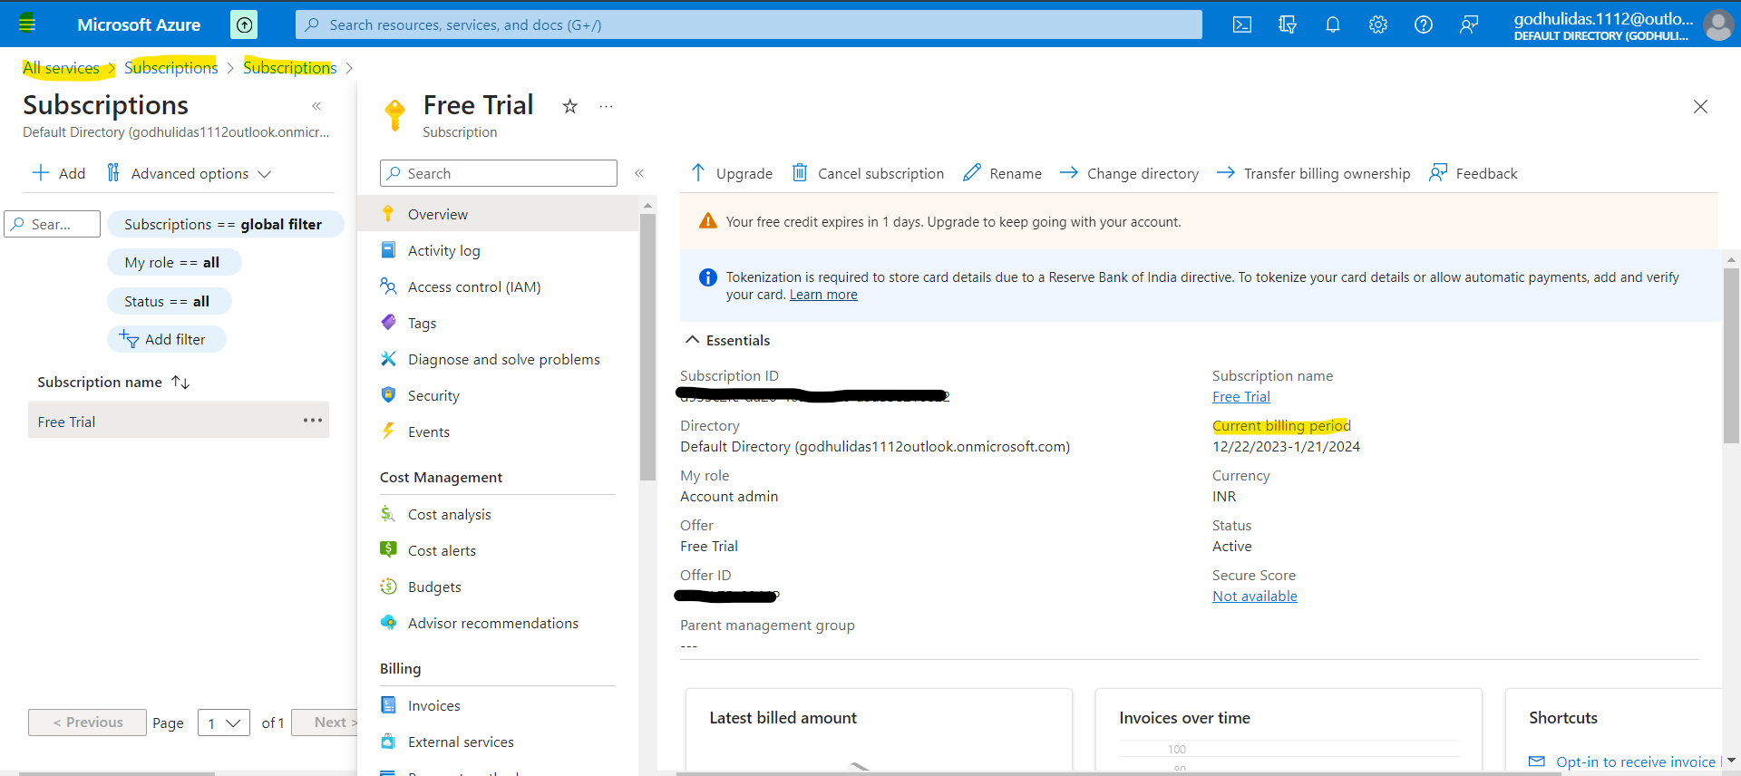

1. Databricks Community edition (web application login, can register without any cloud service linked with your gmail account and giving any ABC company name. If registered with cloud service, it is chargeable so so to use free, should register for community edition. Details shown later.)
2. Power BI desktop(can install in own device and do stuffs without signing in as it would ask for work domain email. Only thing is without signing in, one will not be able to publish the work in Power BI community however one can download the pbix file and showcase for personal use.)

**Issues faced:**

1. SQL server connection issue to Azure – The authentication method should be selected as SQL authentication instead of Microsoft authentication. Follow this video for resolving the issue. -🡪 <https://youtu.be/AvRUWFq-9ZA?si=RWY86vqIFLX9uIKA>
2. Cluster terminated in Databricks- The cluster created gets terminated due to 60 mins of inactivity. So I cloned the cluster to create a new one and continued to create the workspace and following tasks.

2.a> To track down previously created notebook navigate Workspace>Users>mailed with which workspace created. Snapshots below:

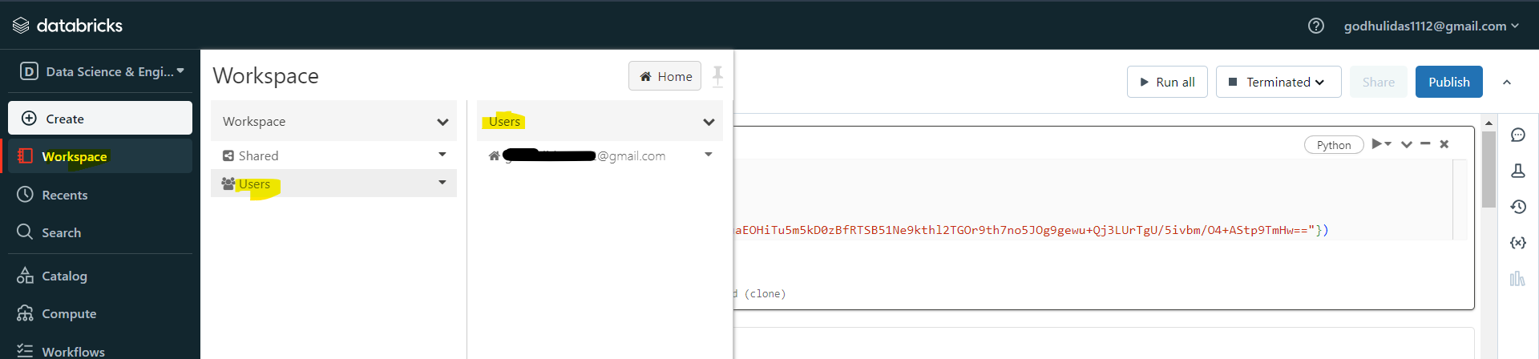

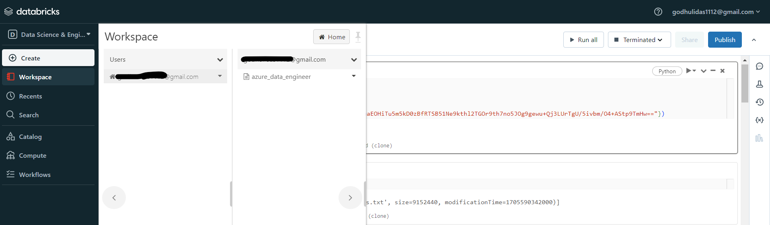

1. Databricks Community Login issue– While trying to re-login I got error as my email entered or password invalid even after giving correct credentials. Also the “Forget Password” was not sending reset link in my registered email. There is the catch. While logging in one has to enter the email without any punctuation and all in lowercase characters even though while registering you have entered punctuation or uppercase character.

**Microsoft SQL Server Management studio**

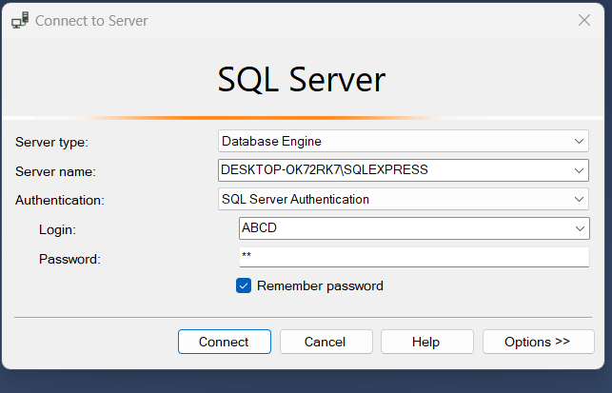

Server name - DESKTOP-OK72RK7\SQLEXPRESS

Login- ABCD

Password – GD

Login failed

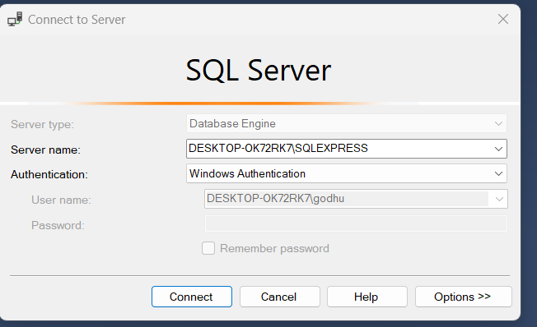

**How to import flat file in SQL server?**

Expand databases>sales>task>Import flat file

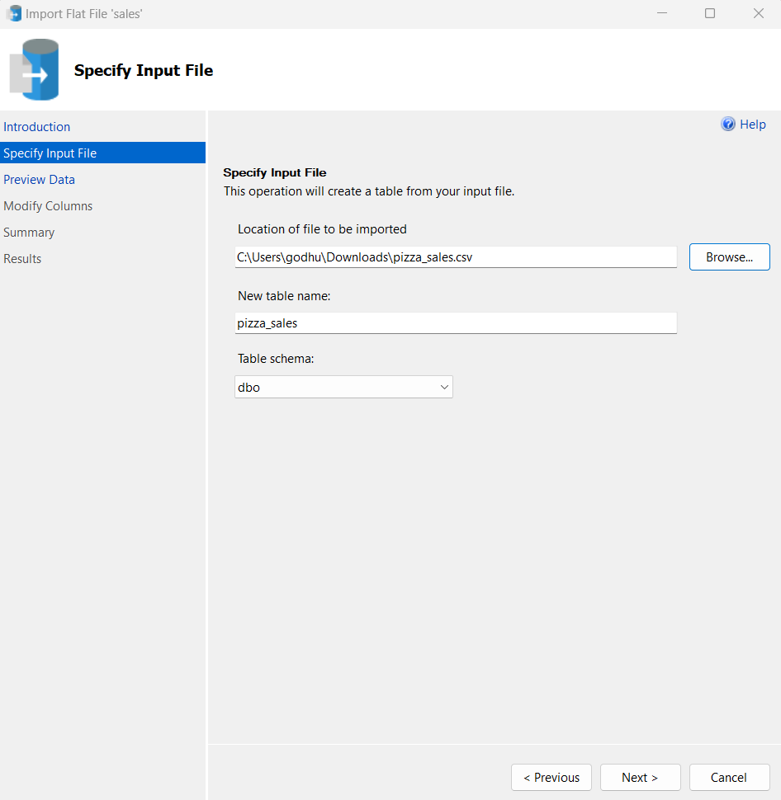

Already performed this step.

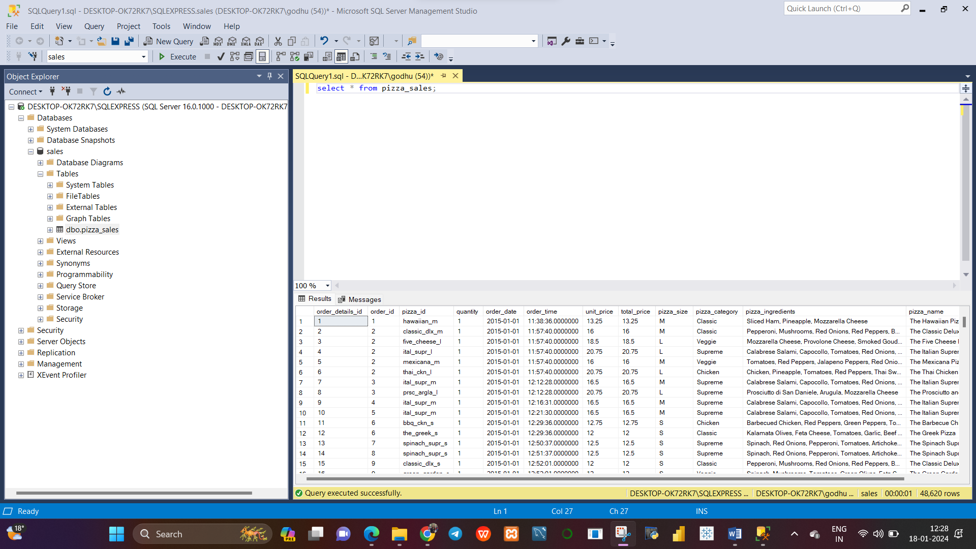

Now data is available at on-prem

**Create SQL database in Azure.**

You tube link –

**Create Azure SQL Database | Azure data engineer ->** https://youtu.be/_UOHOr6XIQU?si=6COymWRyrD3-y0BS

At azure portal, logged in search with SQL databases> Create new database

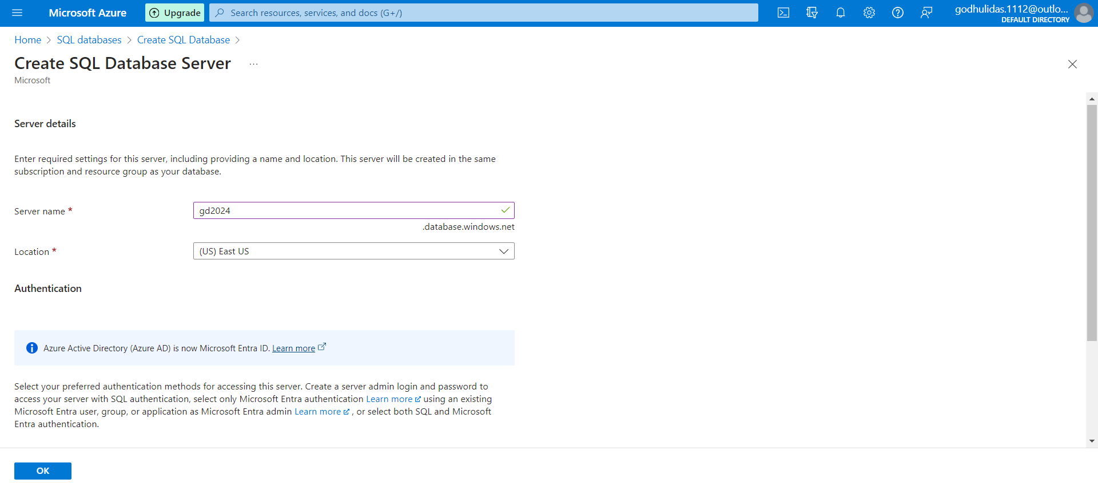

Server name - gd2024

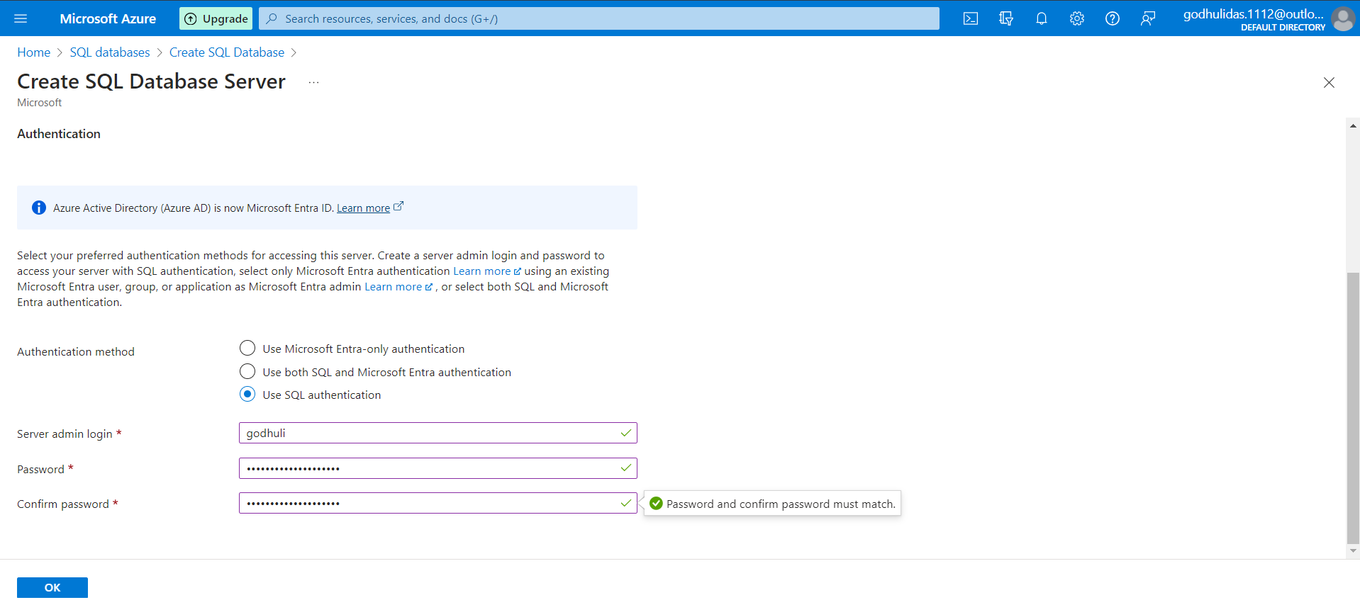

Server admin login – Godhuli

Password – Purposeoflife@111230

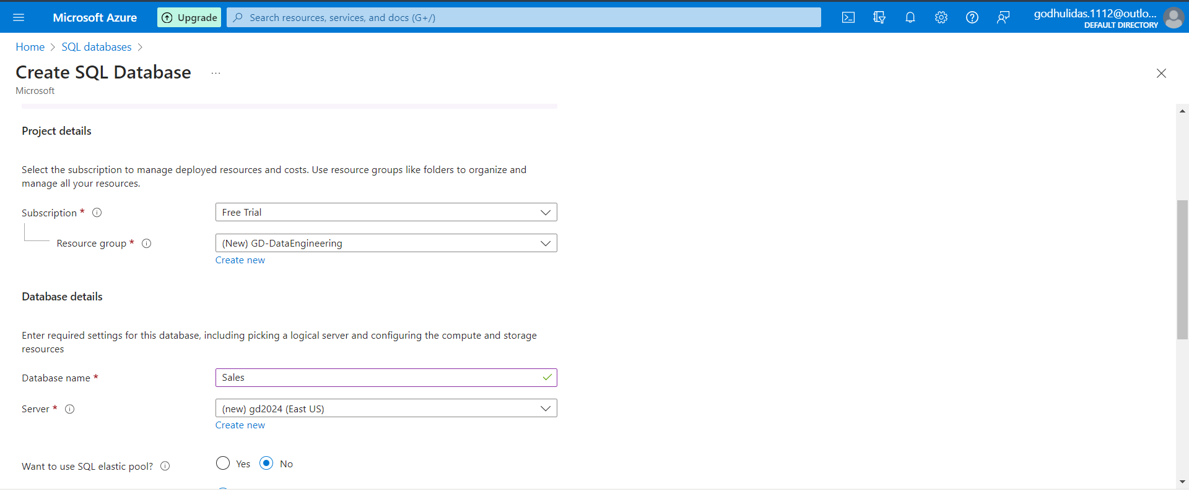

Compute + storage> click Configure database

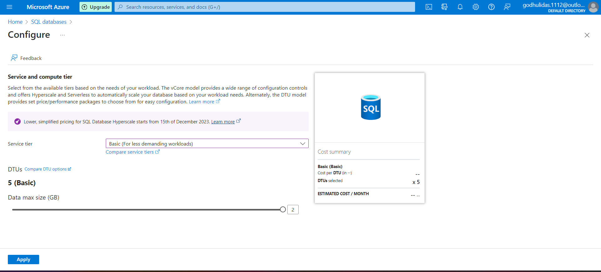 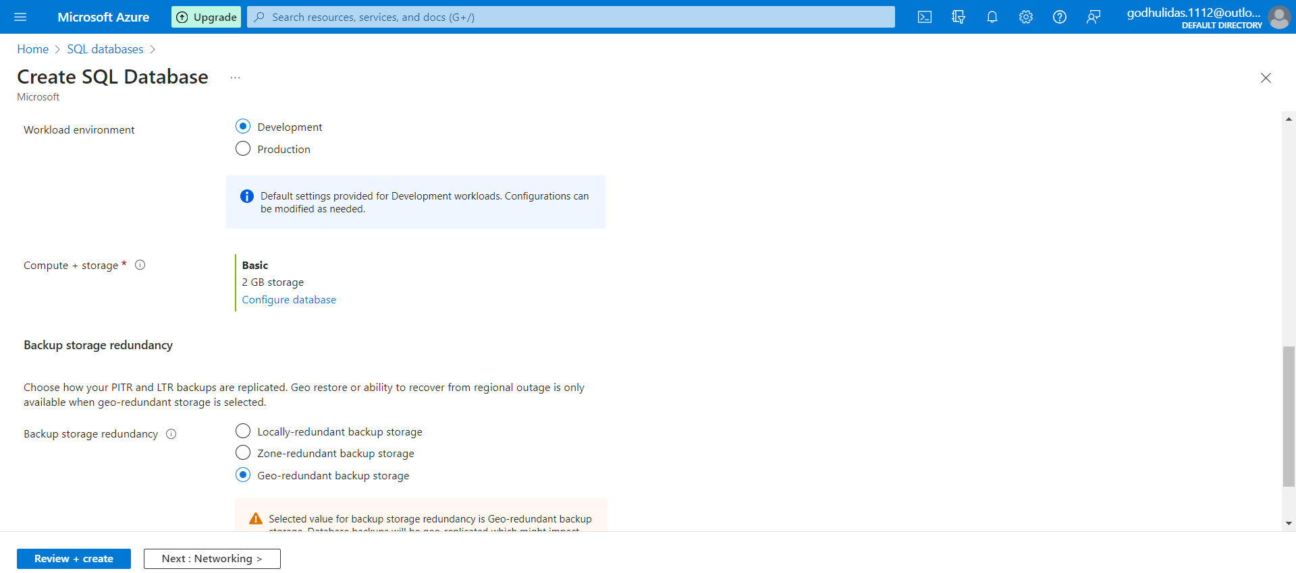 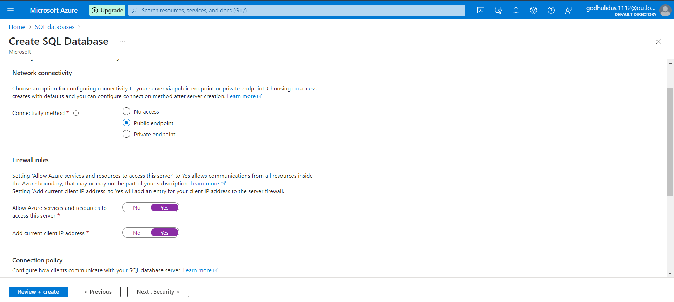

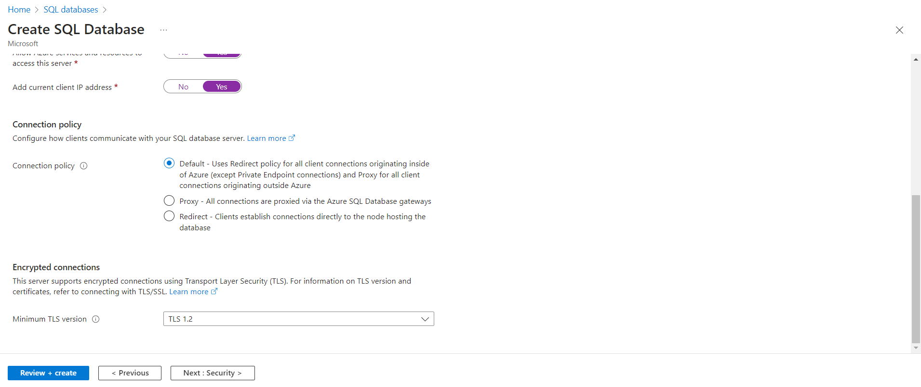 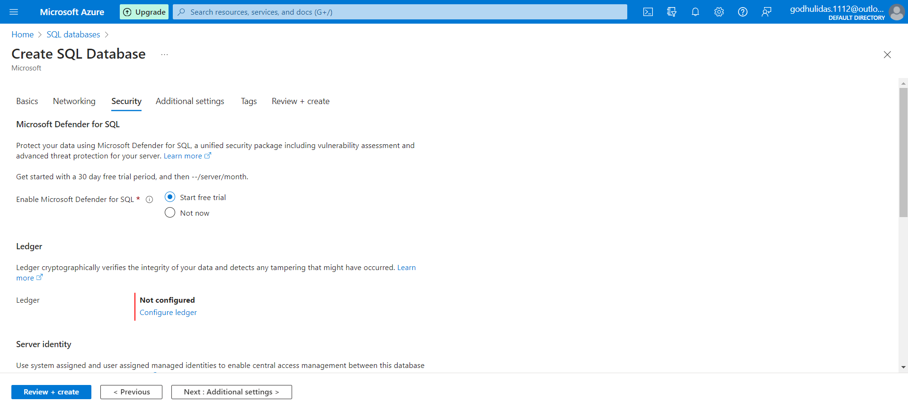

Keep all other options as it is

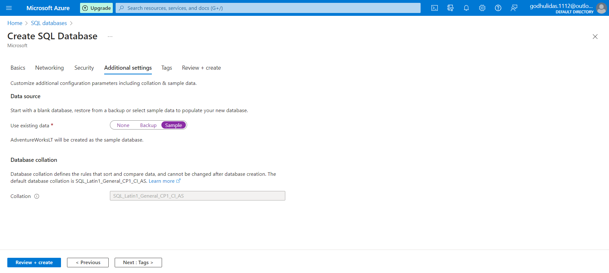

After Next>Review and Create

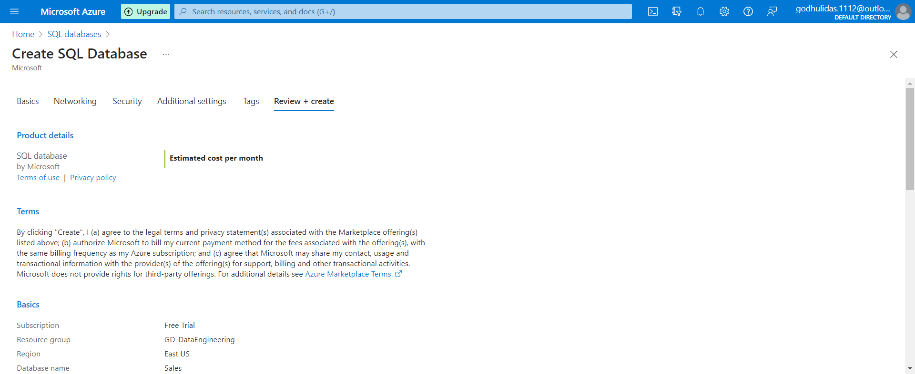 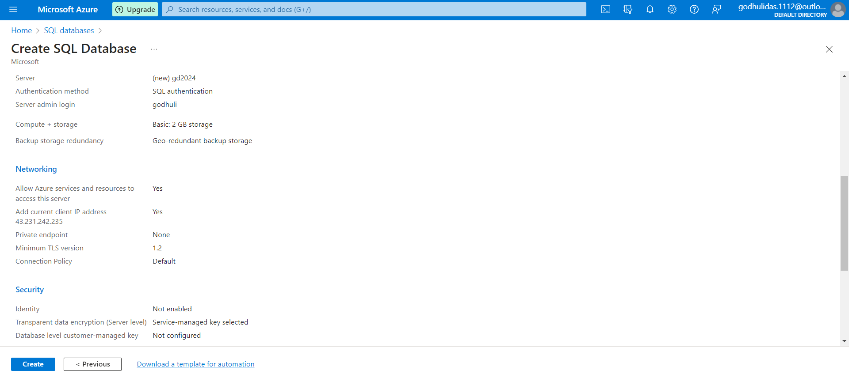 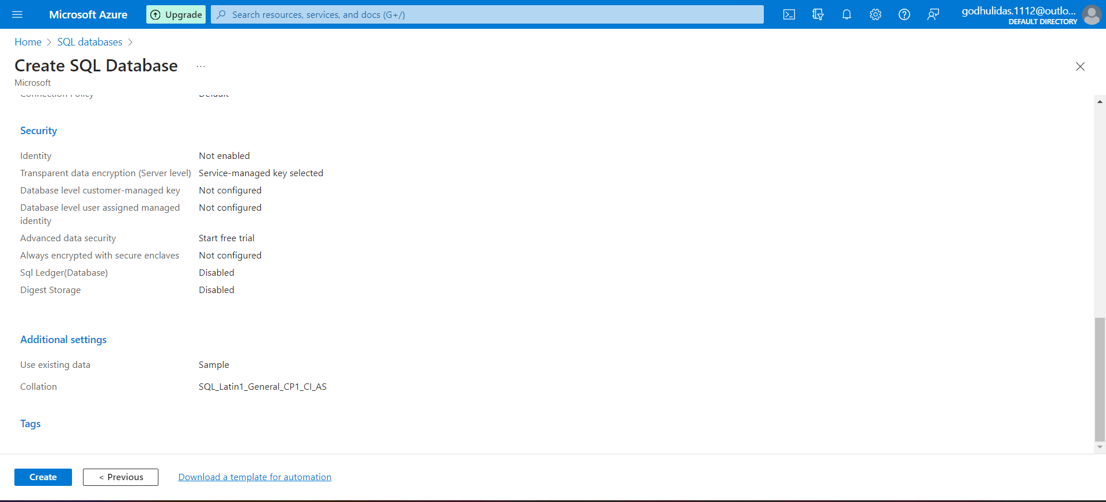

Click on Create

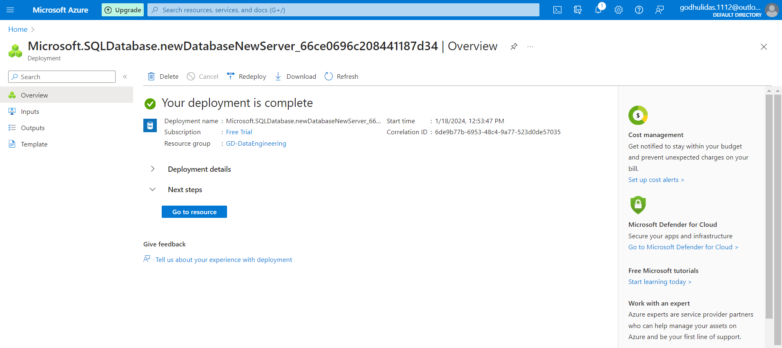

Click on Go To Resource

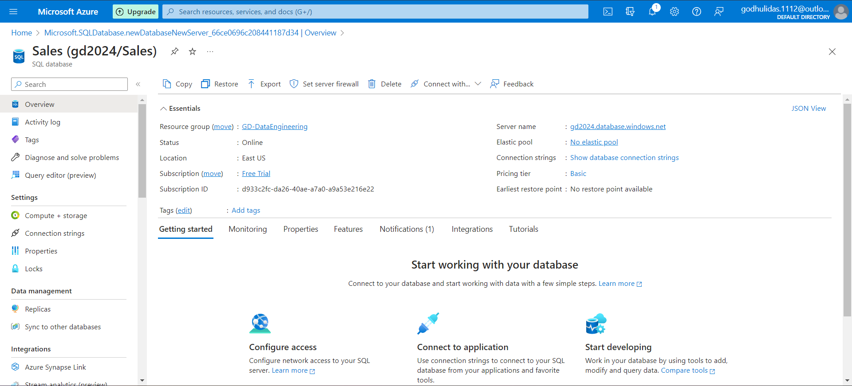

Click on  Query editor (preview) from left side pane.

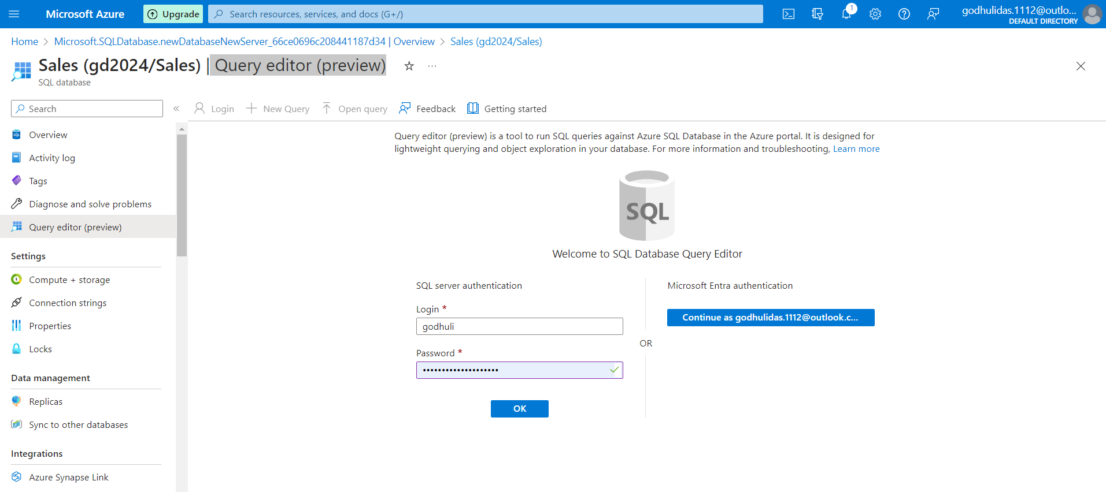

Login with credentials,as provided while creating(screenshots above)

In this step some firewall settings might have been needed for production environment but here not needed.

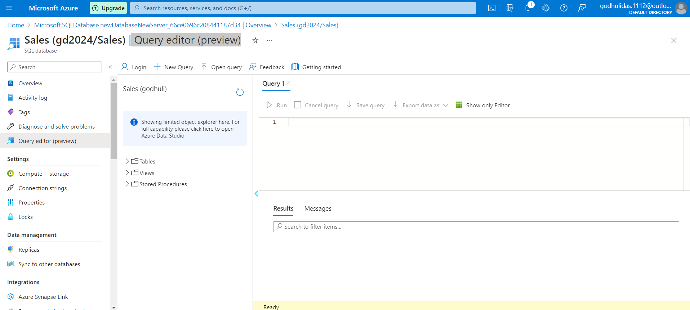

**Create Azure Storage account**

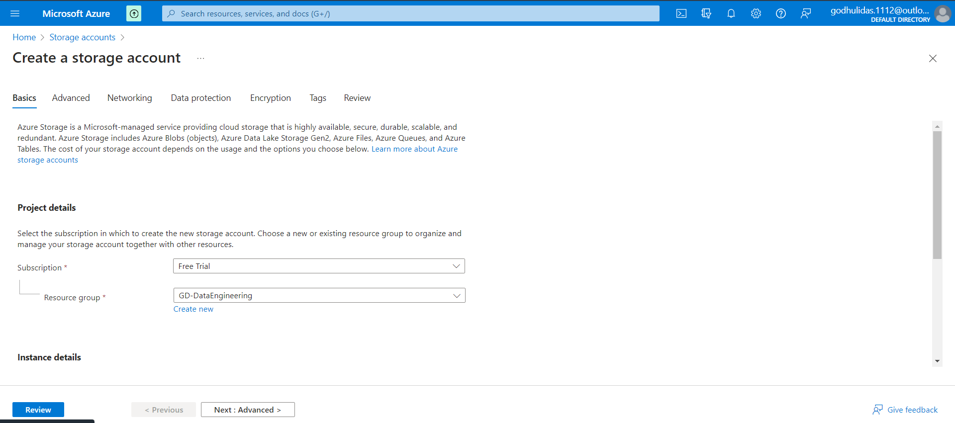

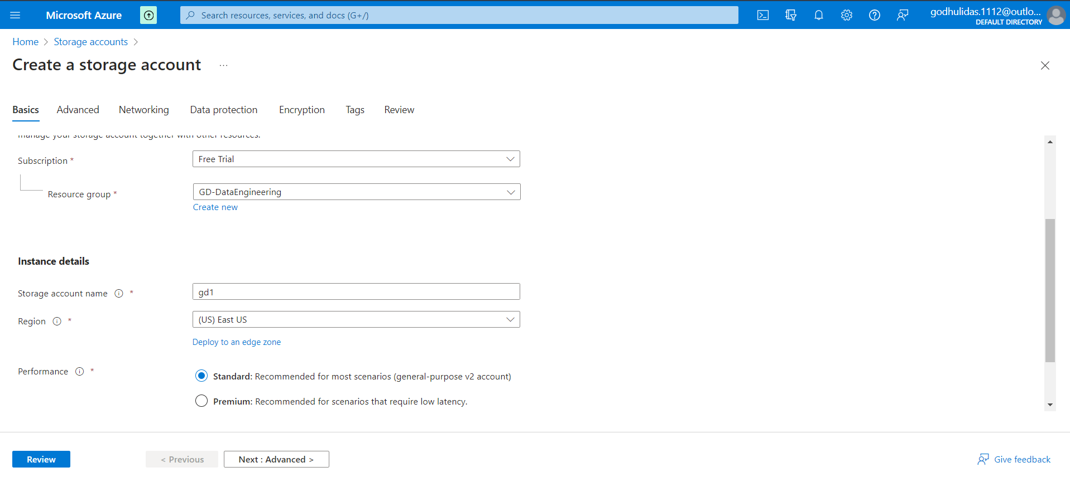Click on Next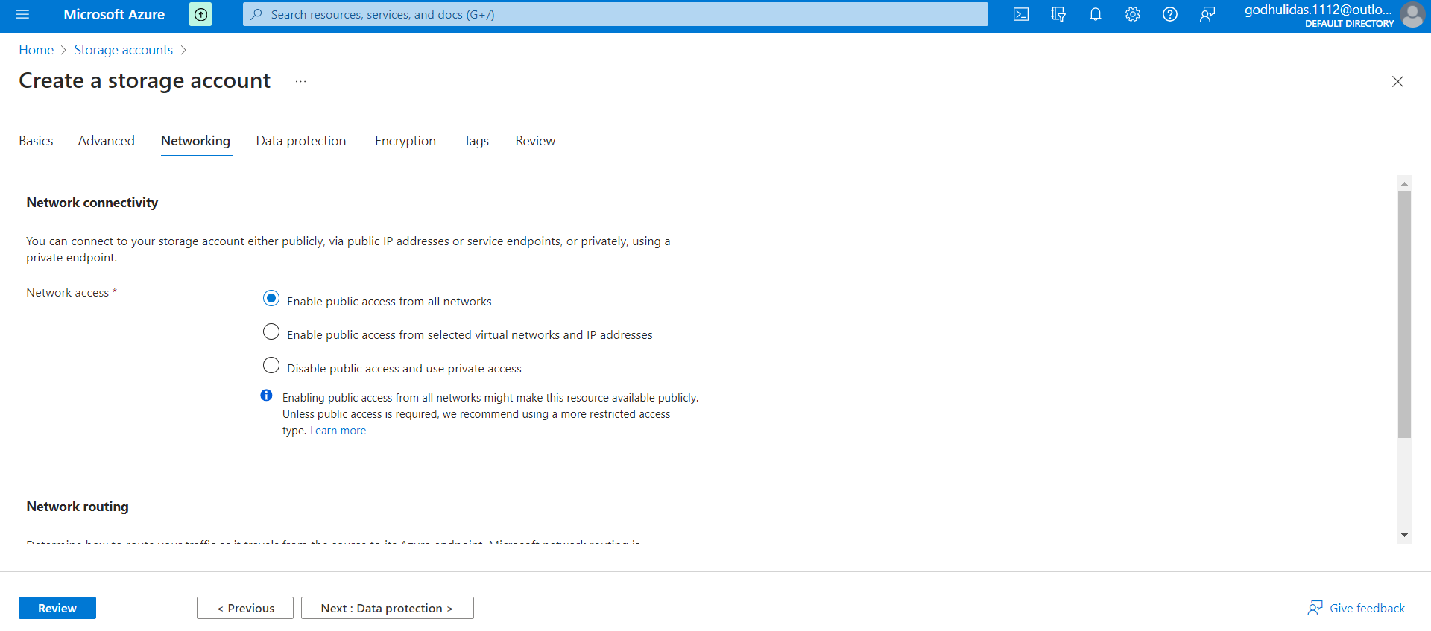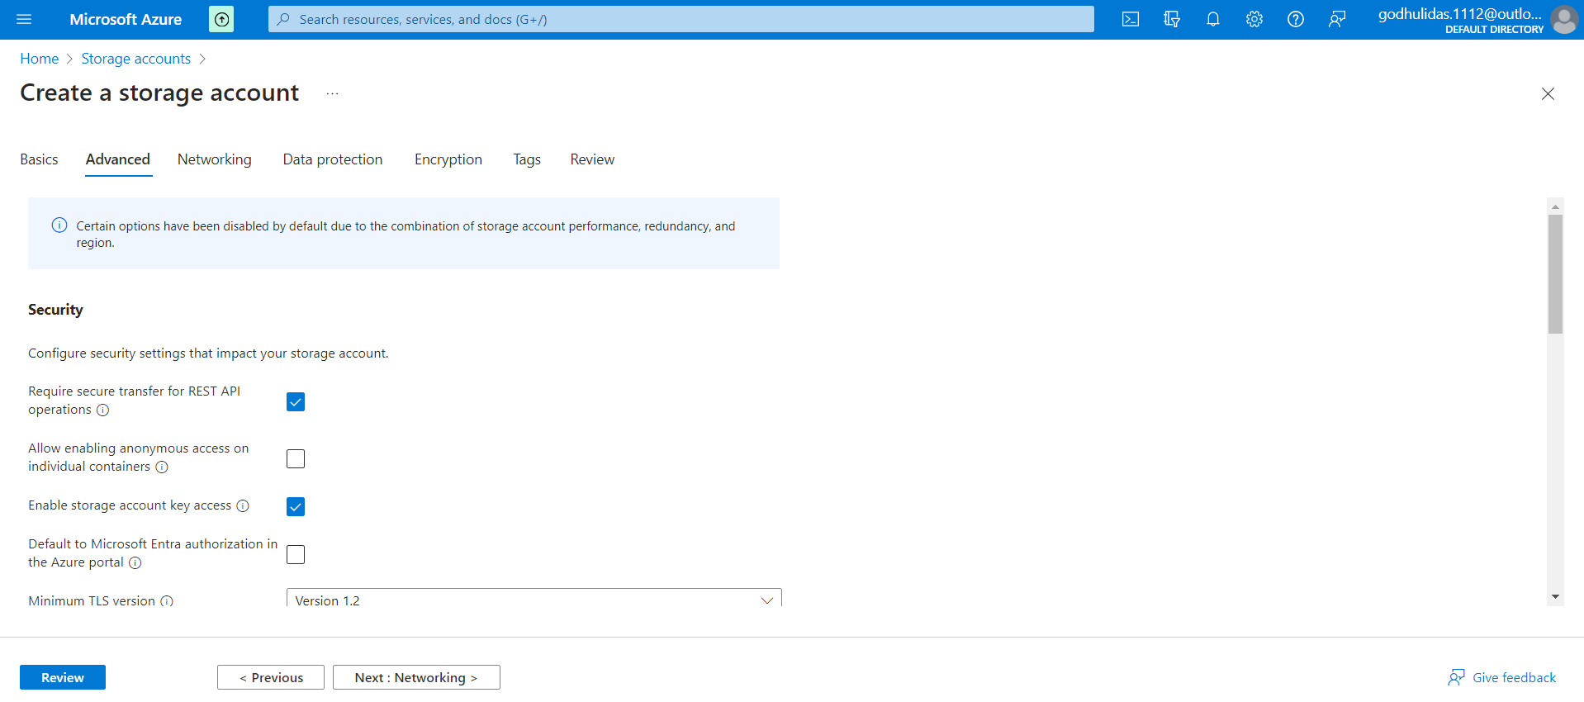

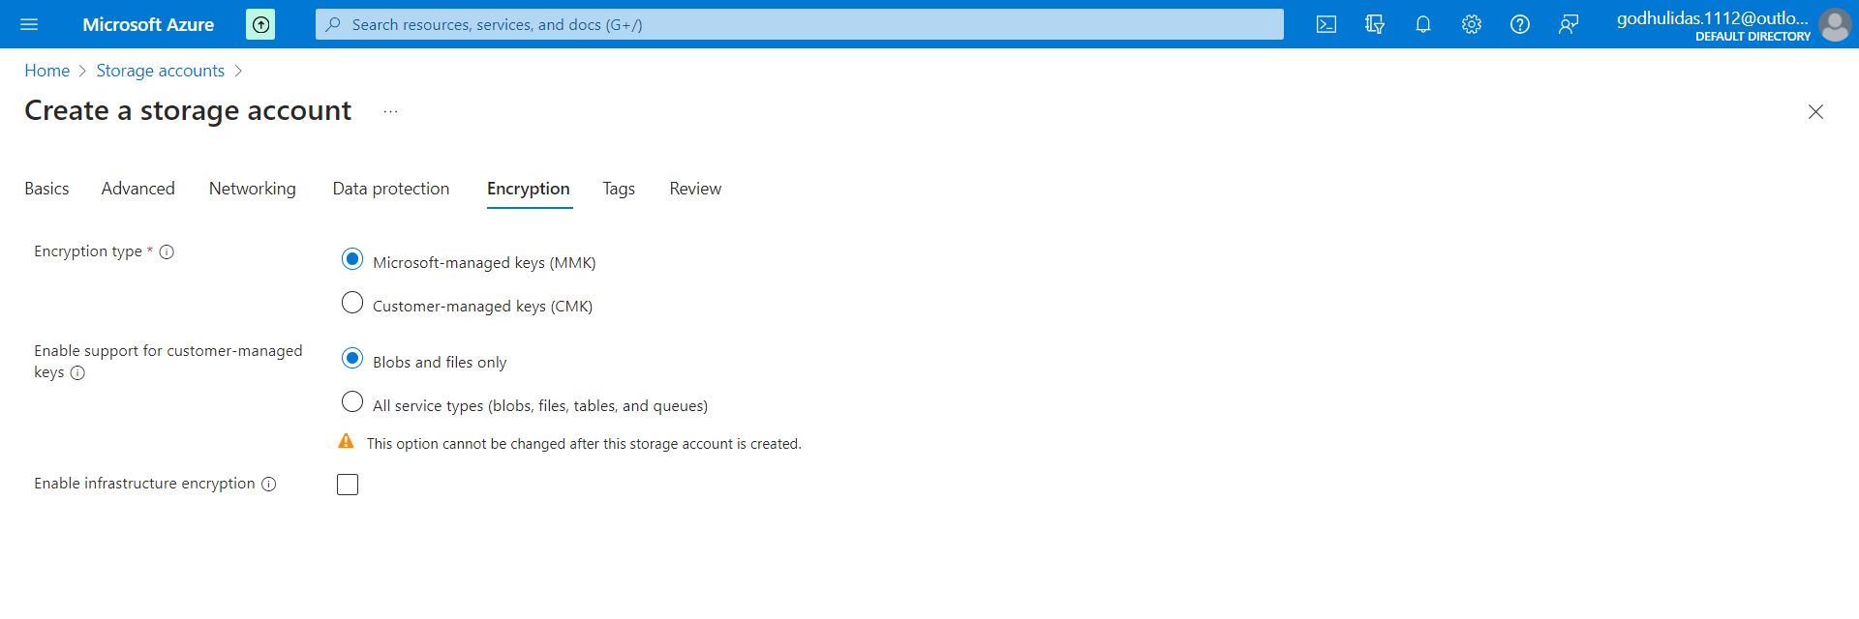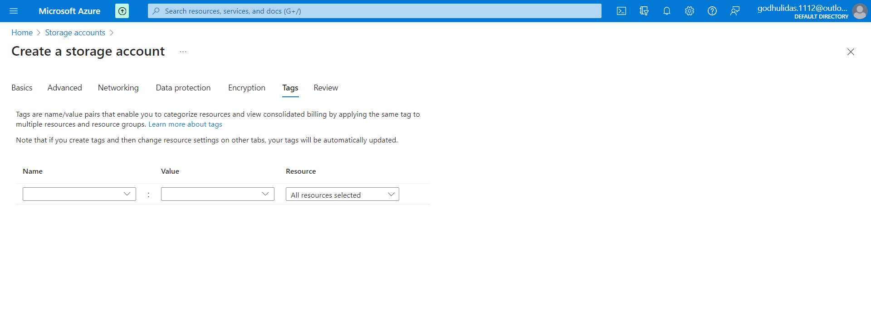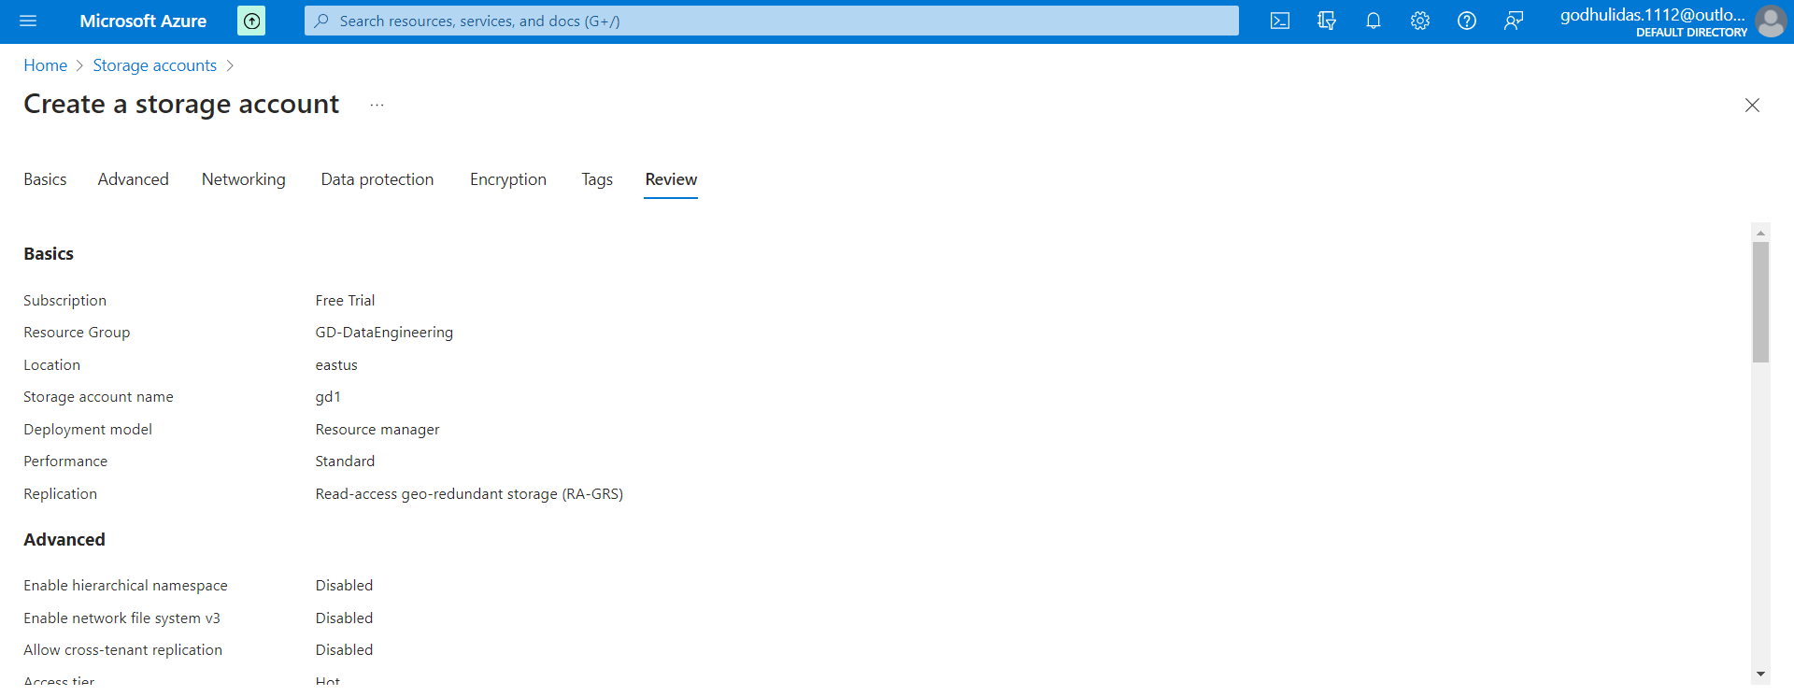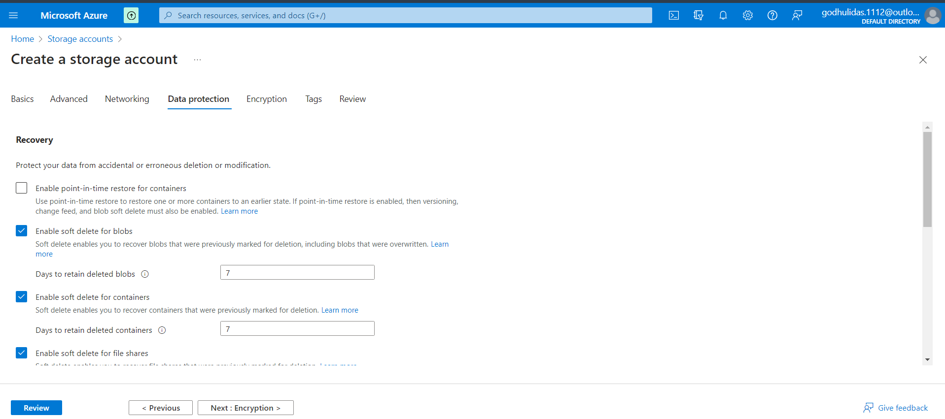

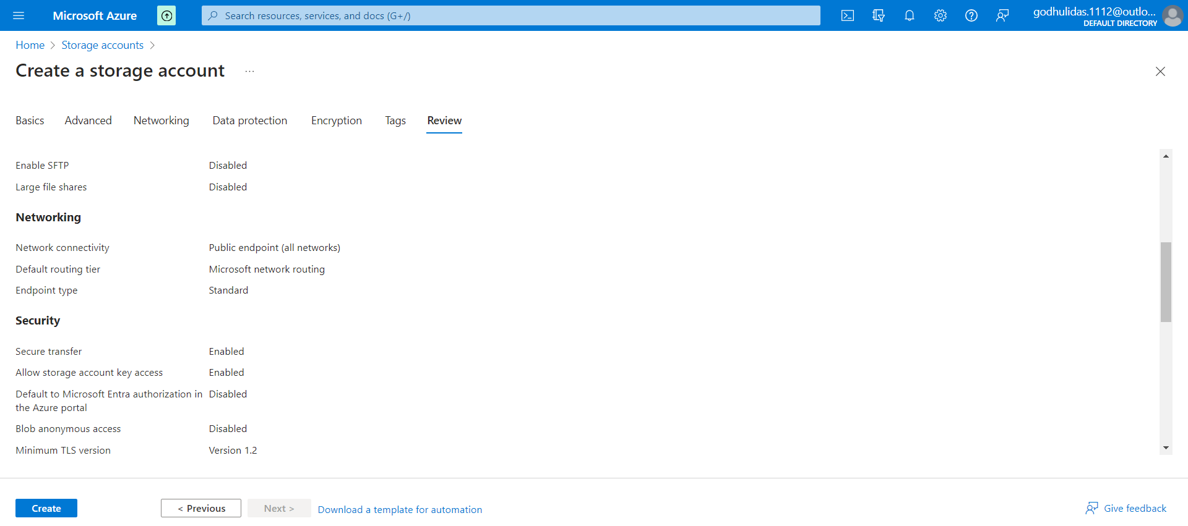

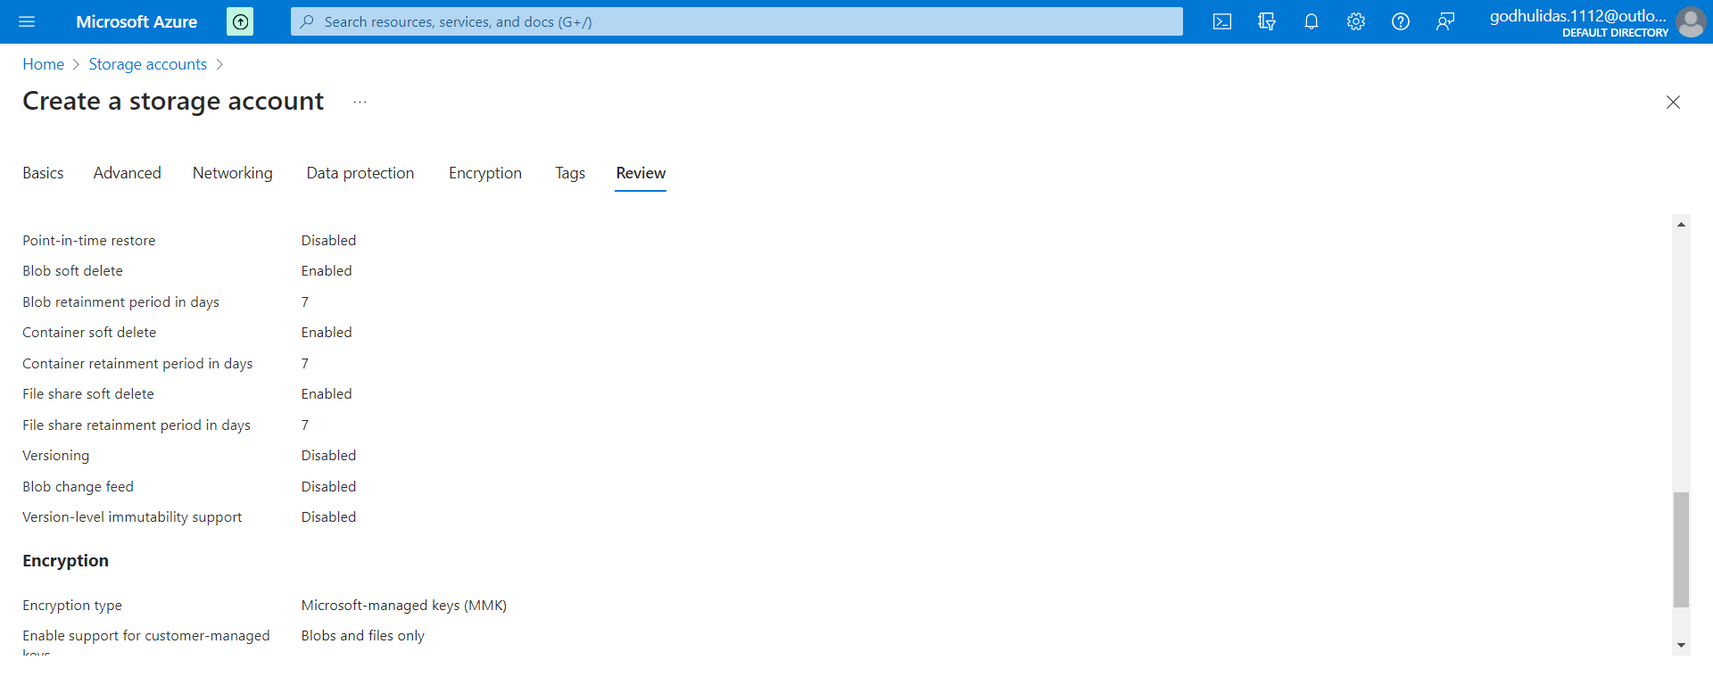

Click on Create

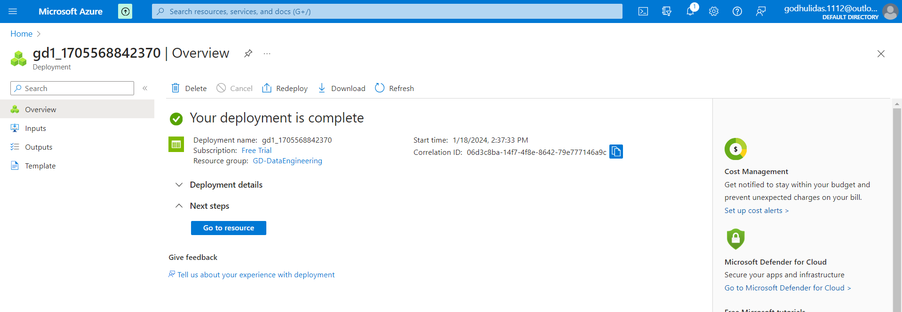

Container creation

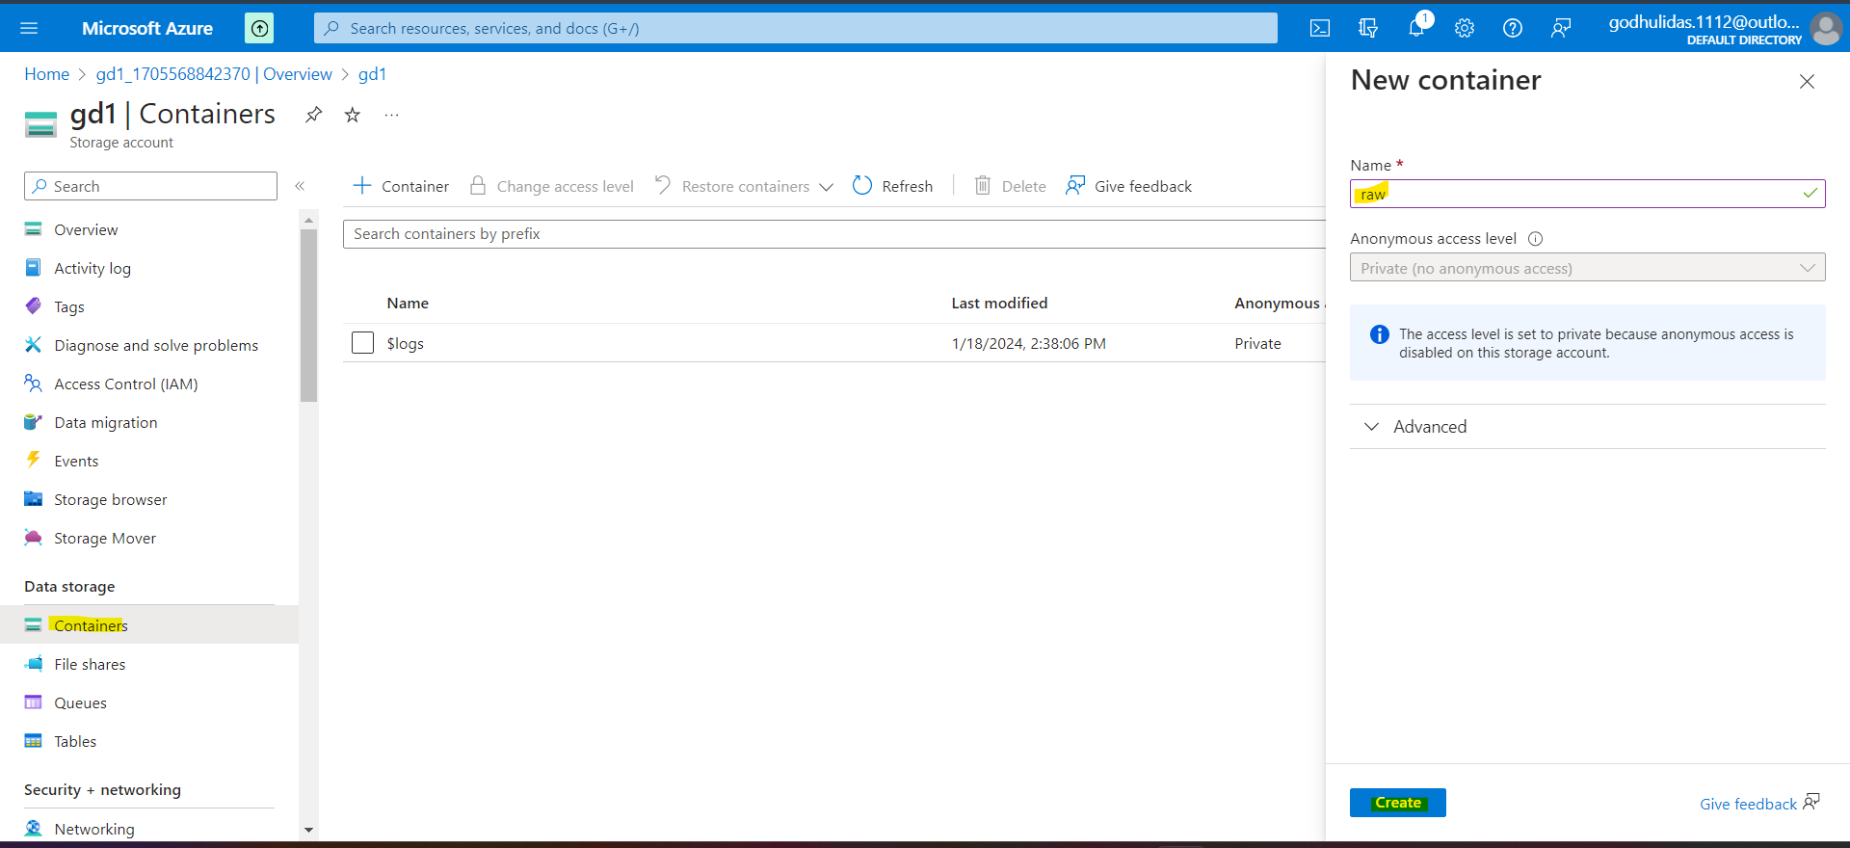 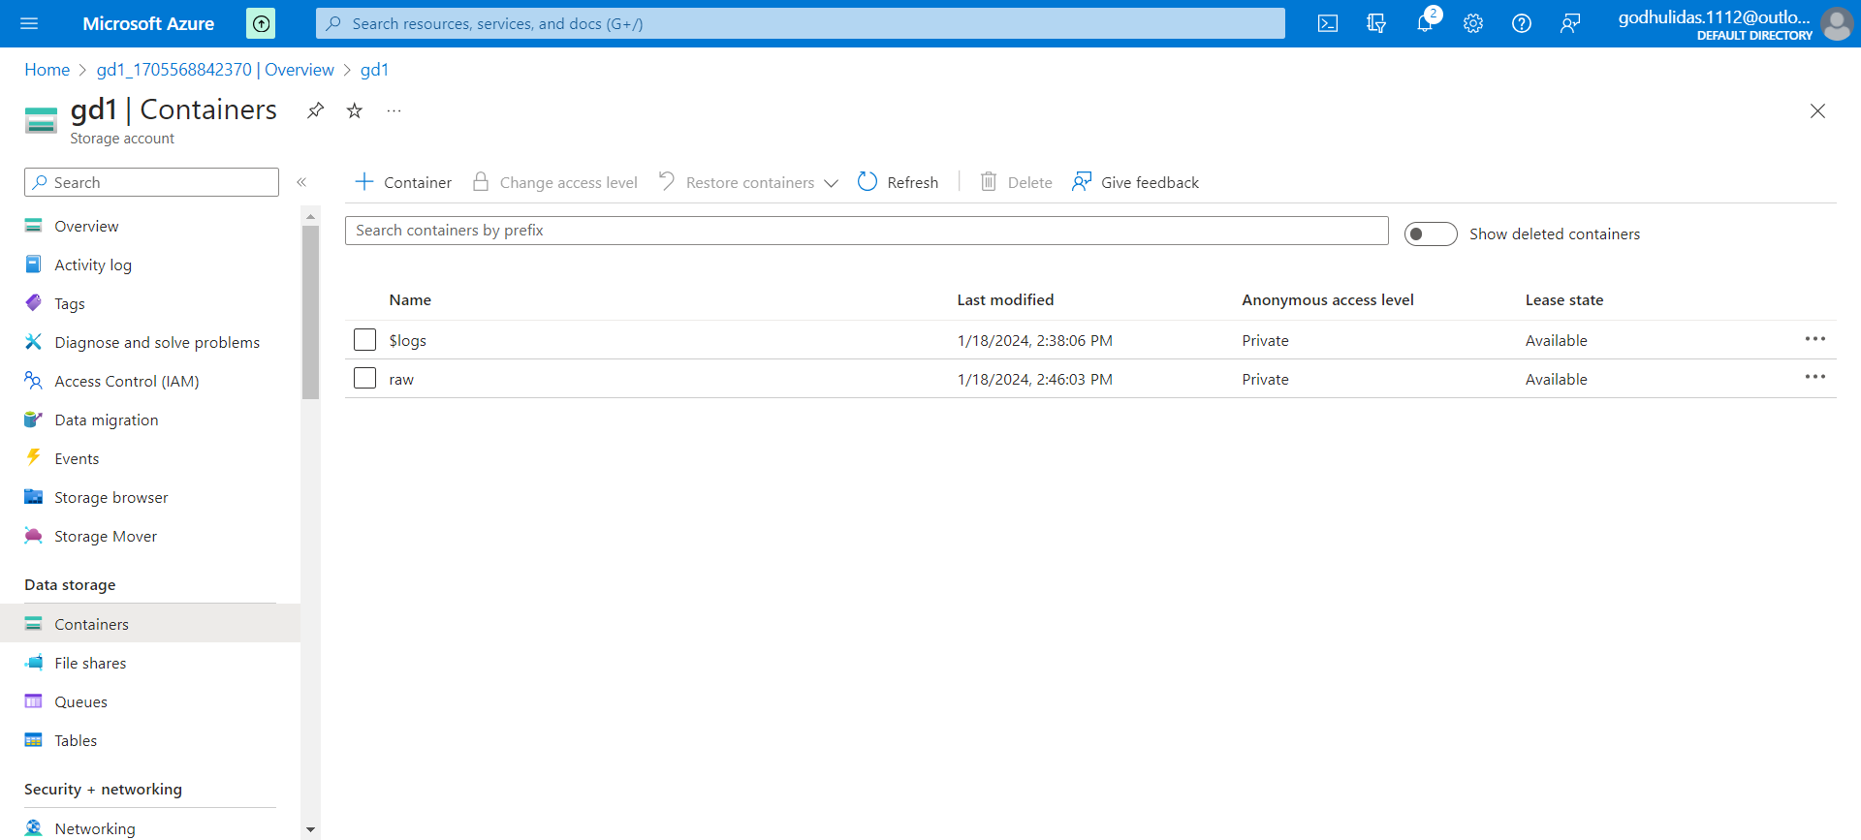 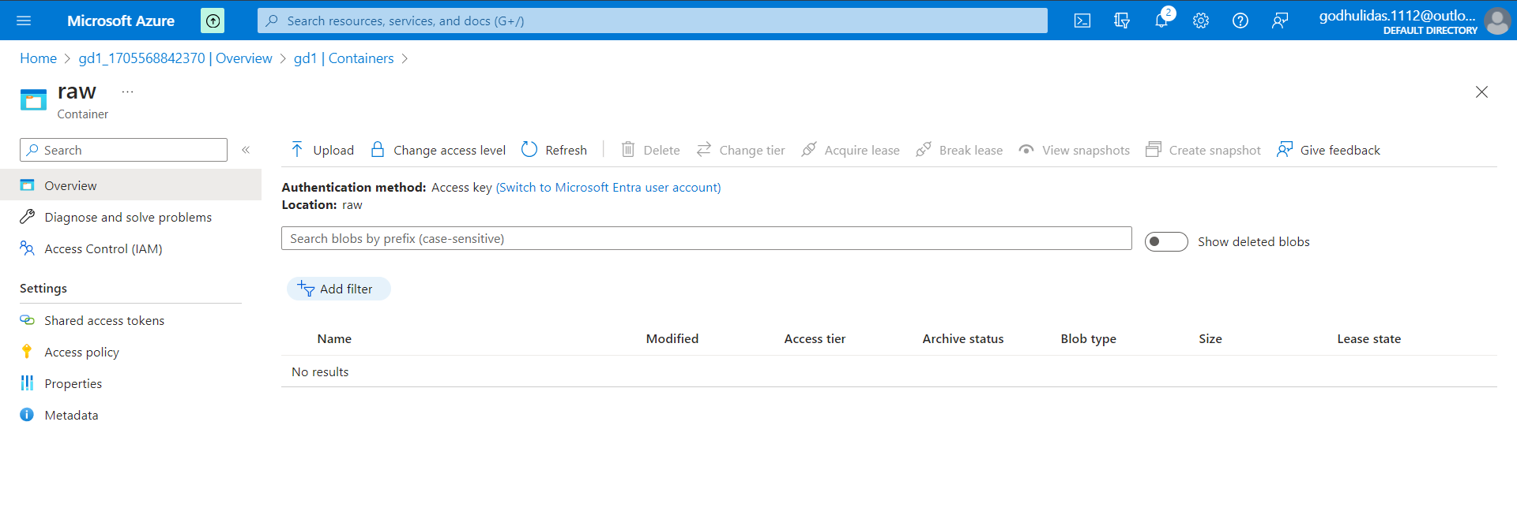

This is empty as there is no data pipeline. Once pipeline created we will move data from SQL server to this location.

**Create Azure Data Factory**

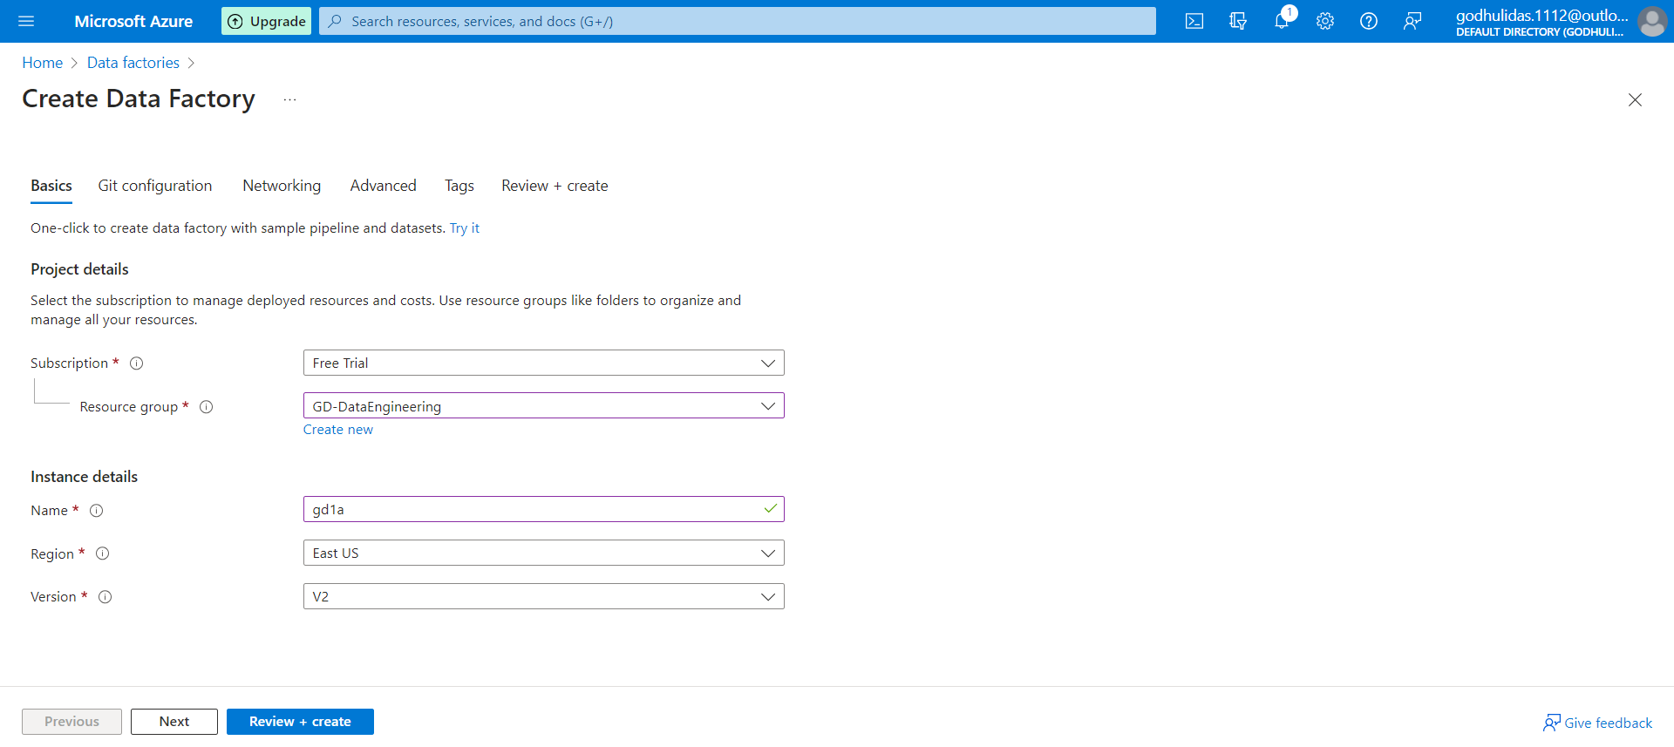

## Instance details

Name - gd1a

Click on Review+Create

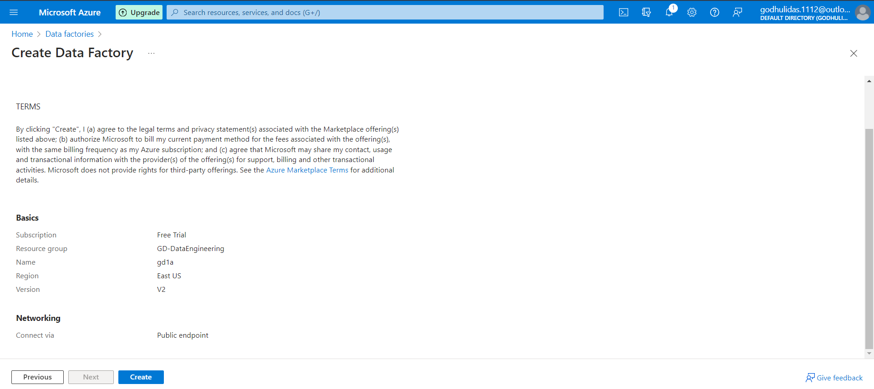Click on Create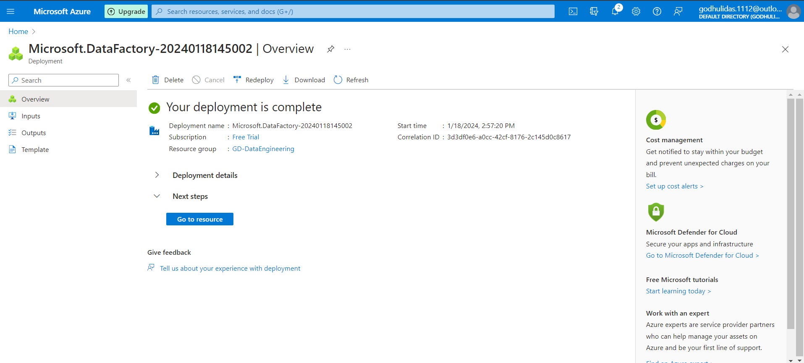

Click on Go to resource

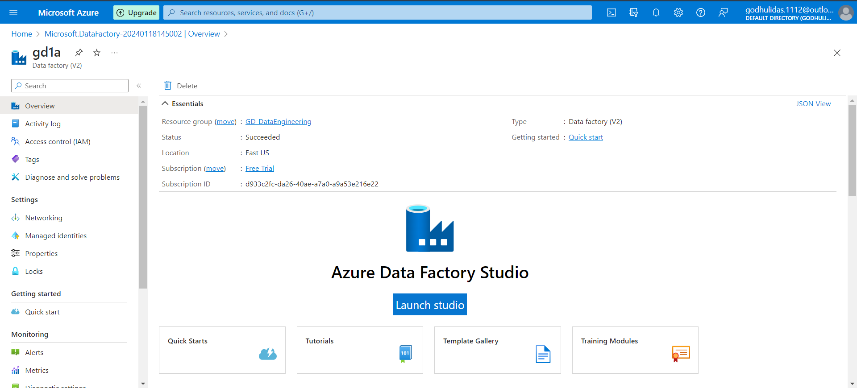Click on Launch studio

In this data factory studio, we will create a data pipeline and move on prem data from SQL server to cloud space.

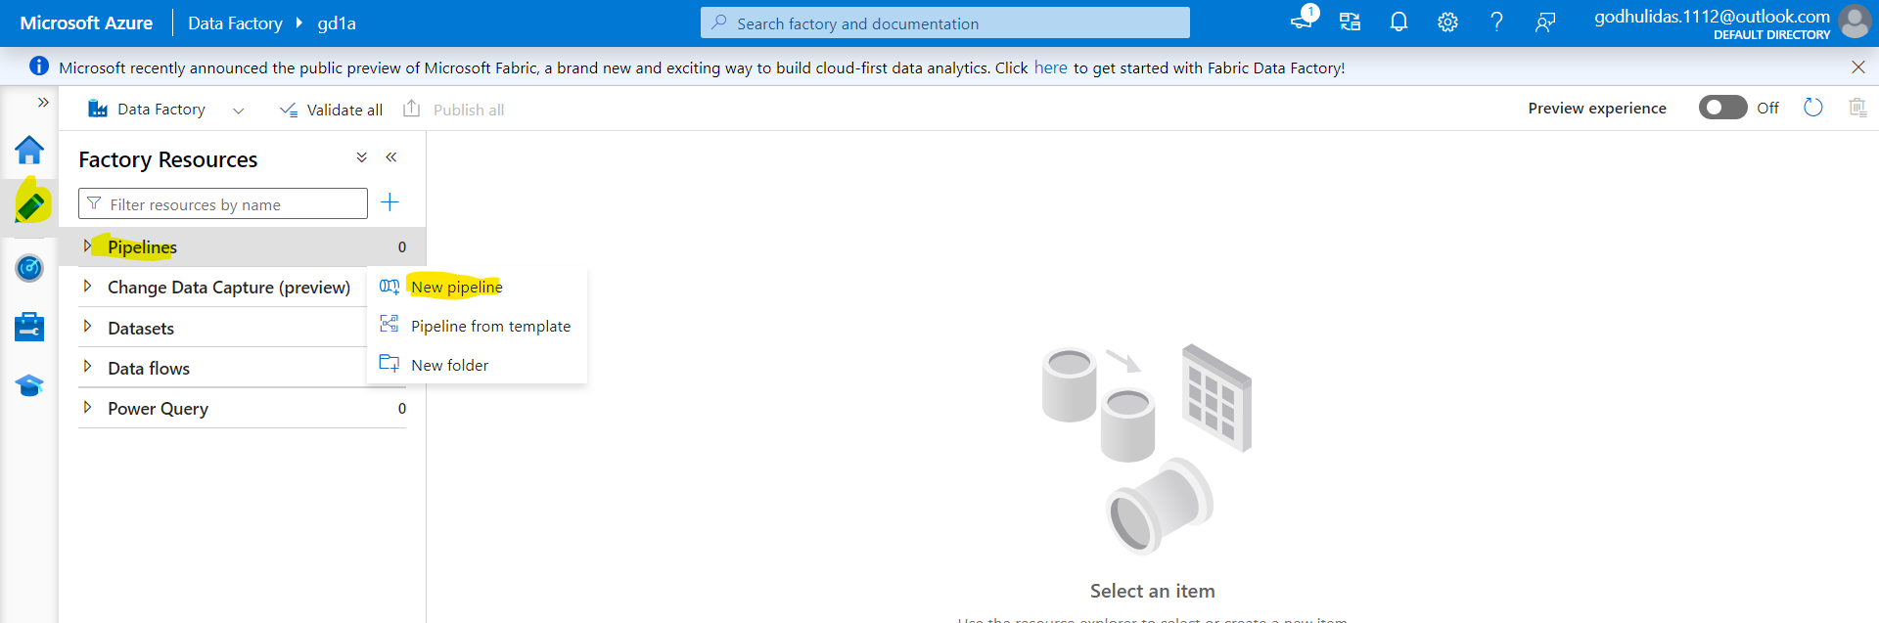

Here Integration runtime is required to migrate on prem data to cloud space. 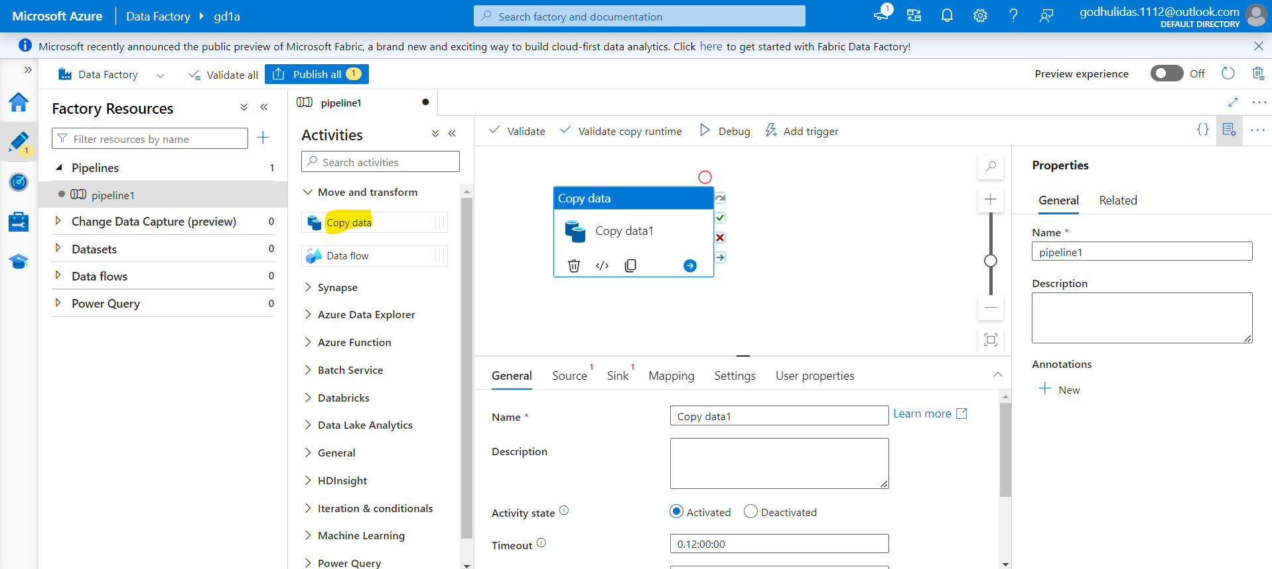

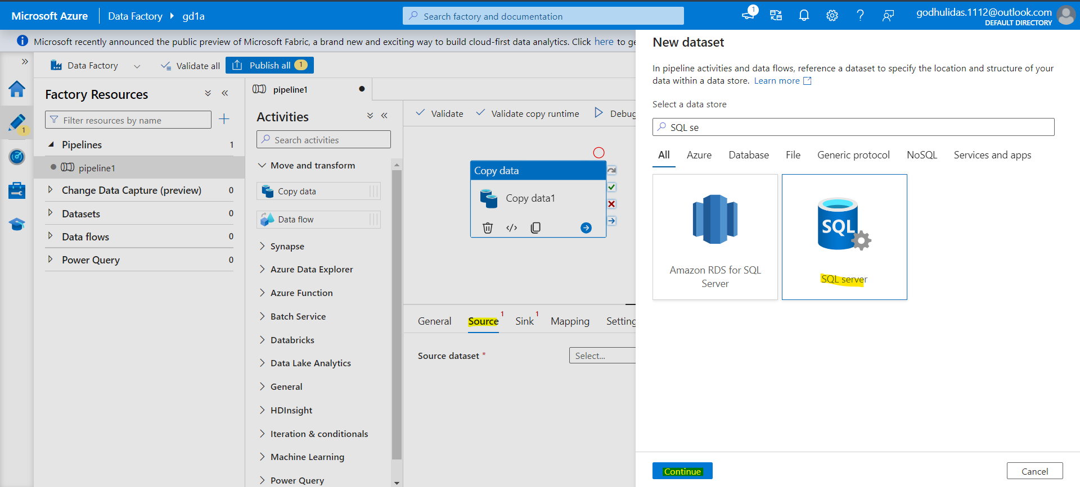

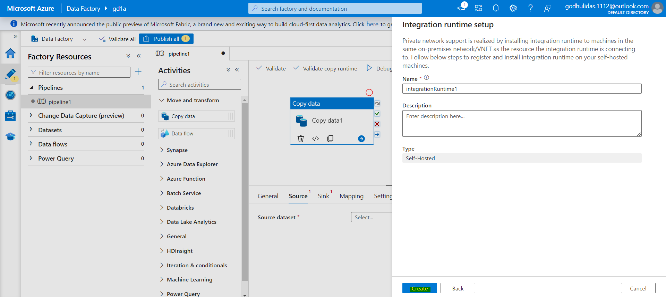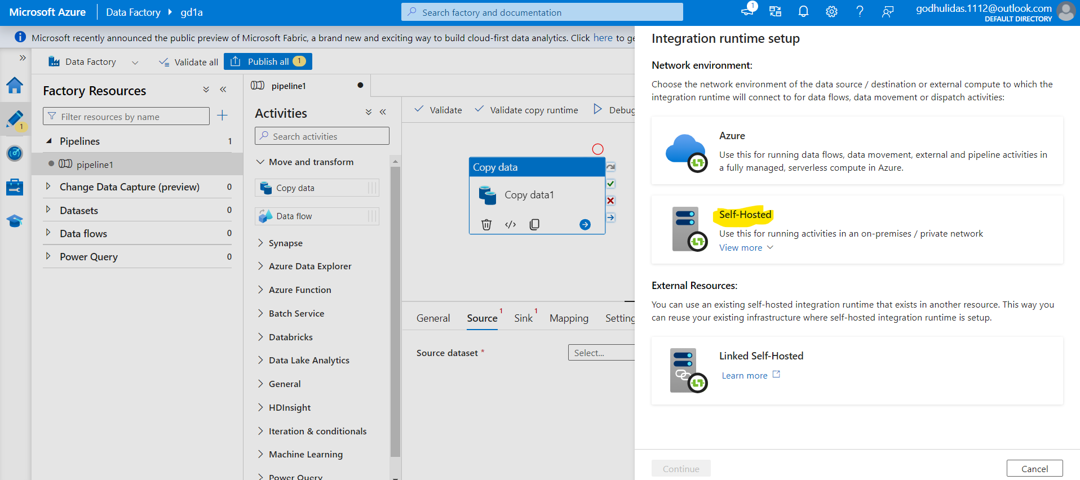 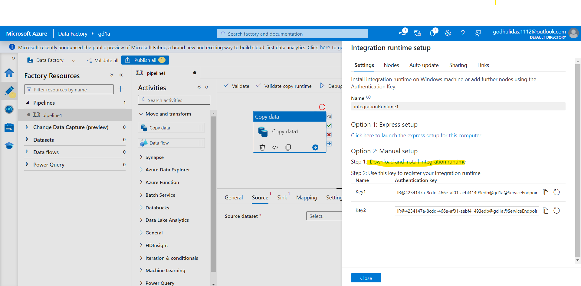

**Microsoft Integration Runtime download**

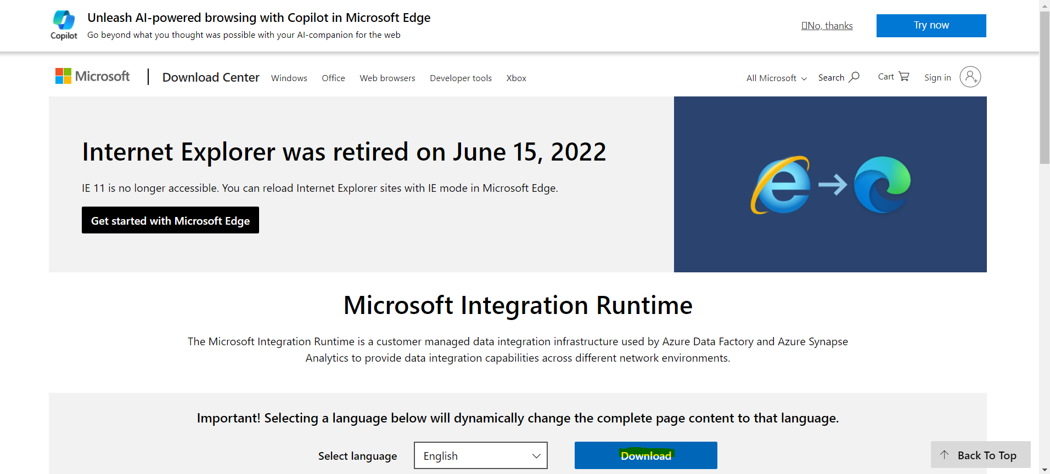

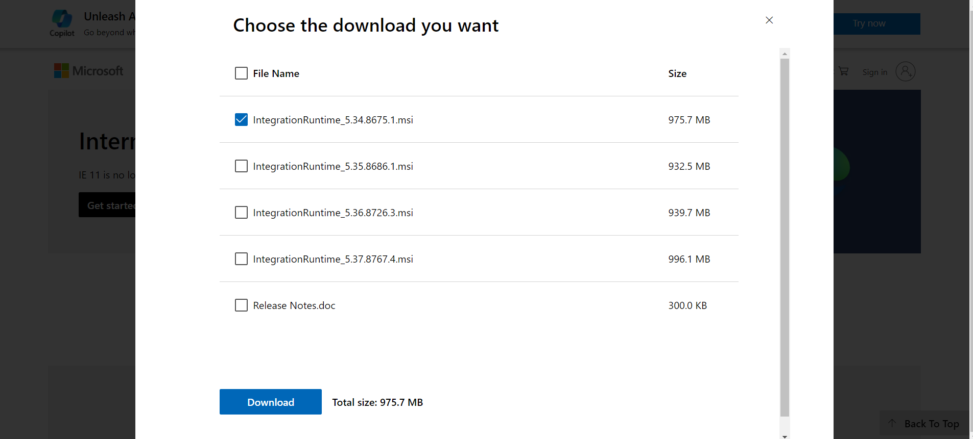

This process is lengthy and might ask to change

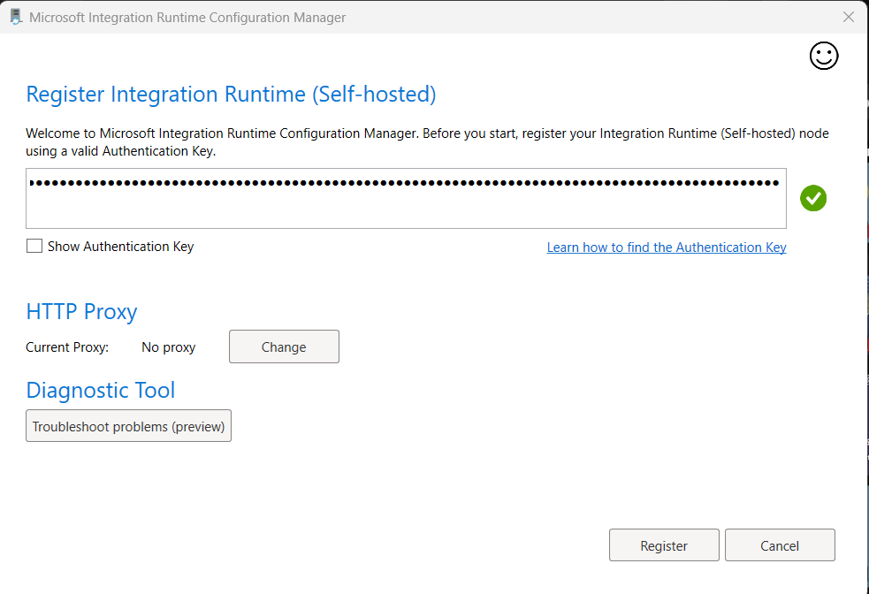

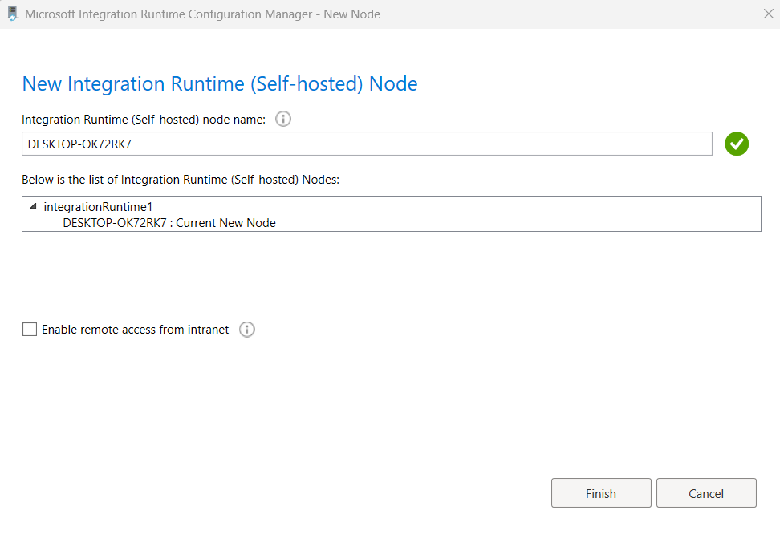

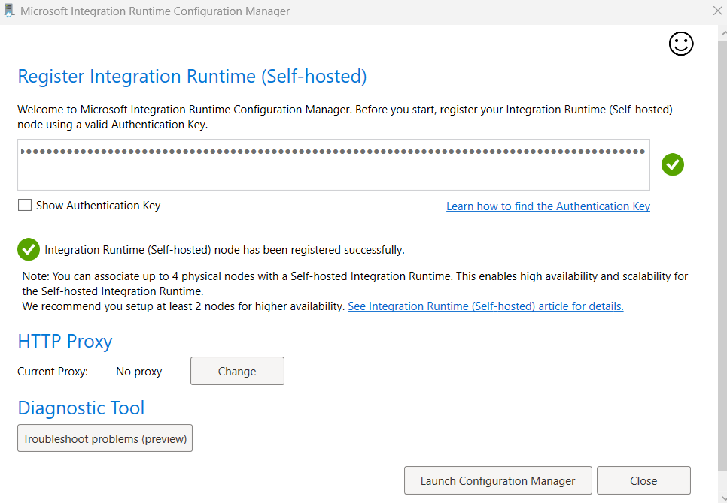

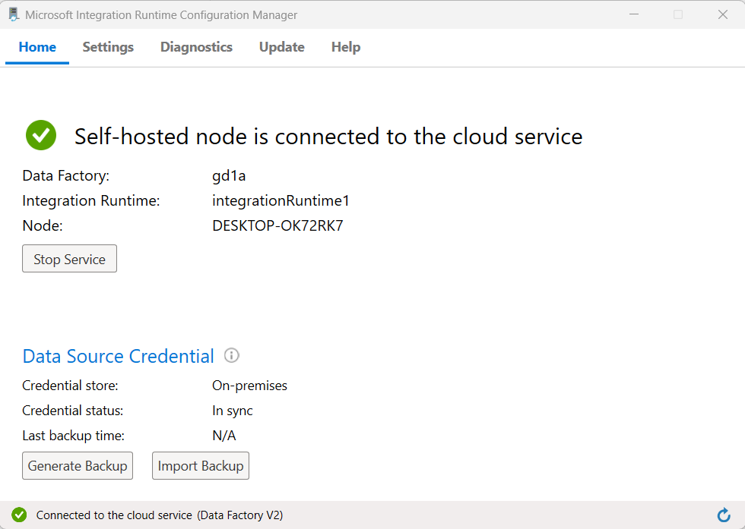

I faced issue while testing connection between Azure data factory and SQL server via Integration runtime, so I have to enable mixed mode authentication for establishing connection.

**Enabling the mixed mode authentication.**

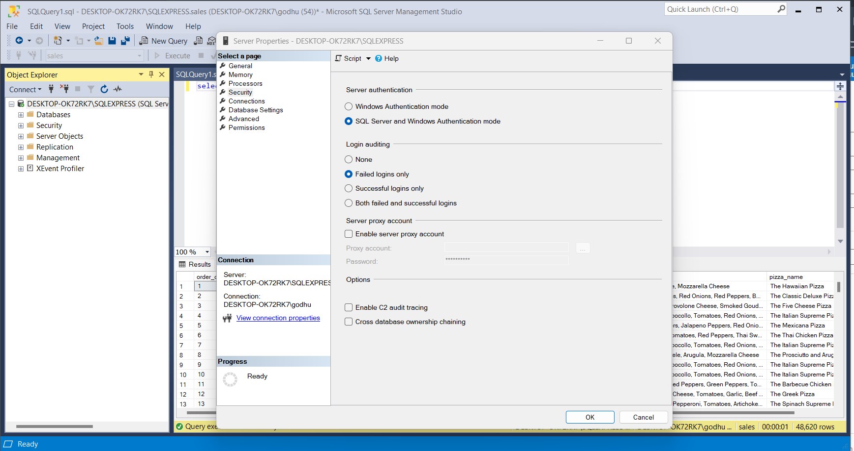

V IMP ::: Follow link 🡪 https://youtu.be/AvRUWFq-9ZA?si=RWY86vqIFLX9uIKA

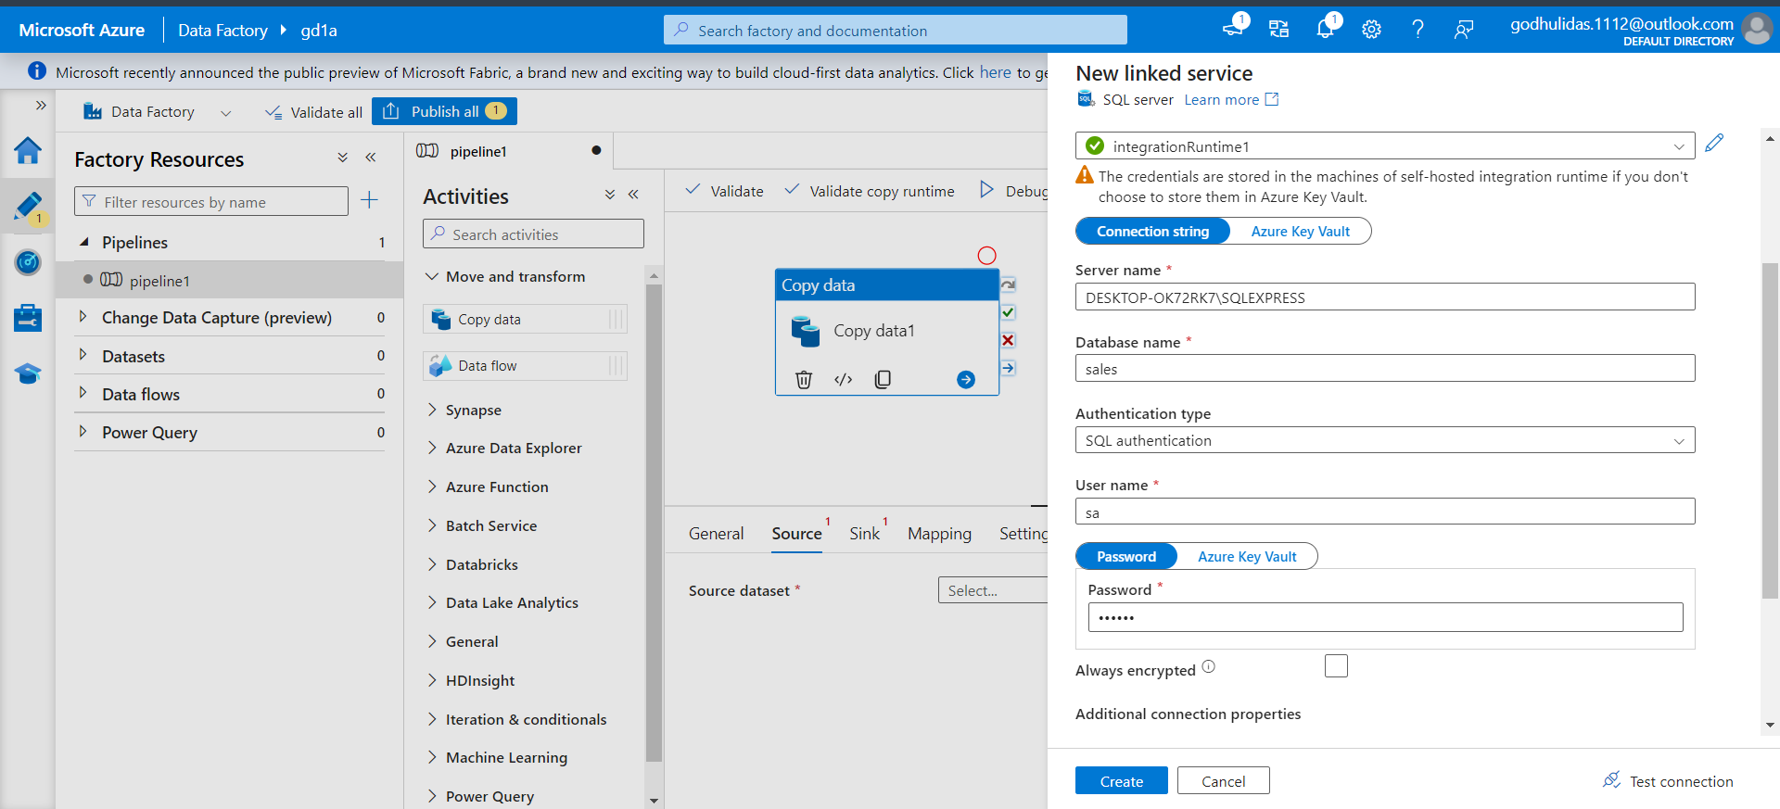

Username – sa

Password – 111230

Click on Create

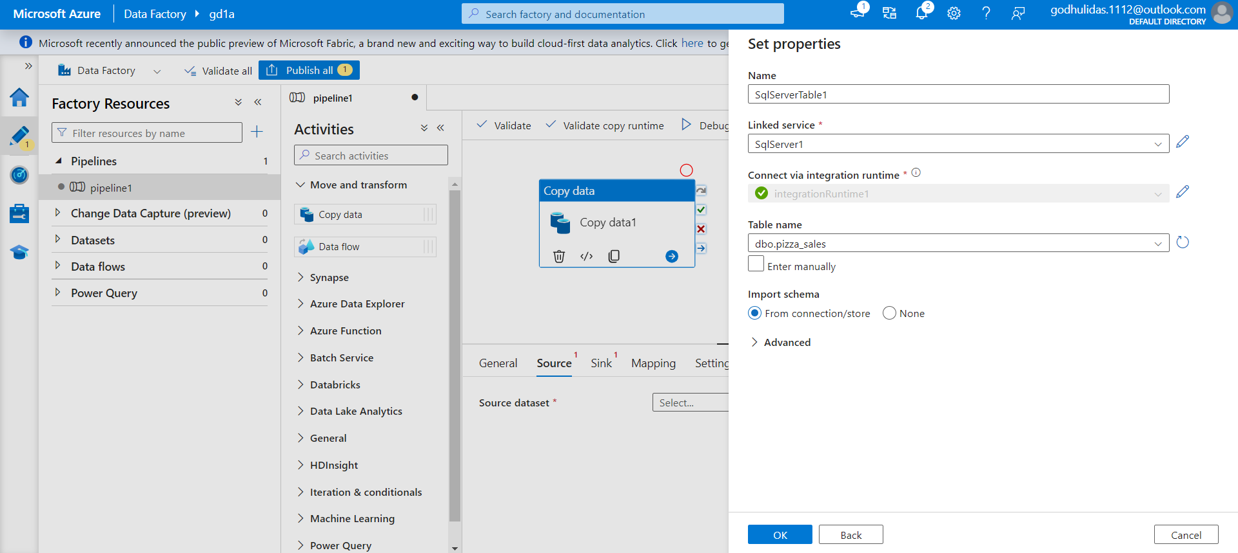 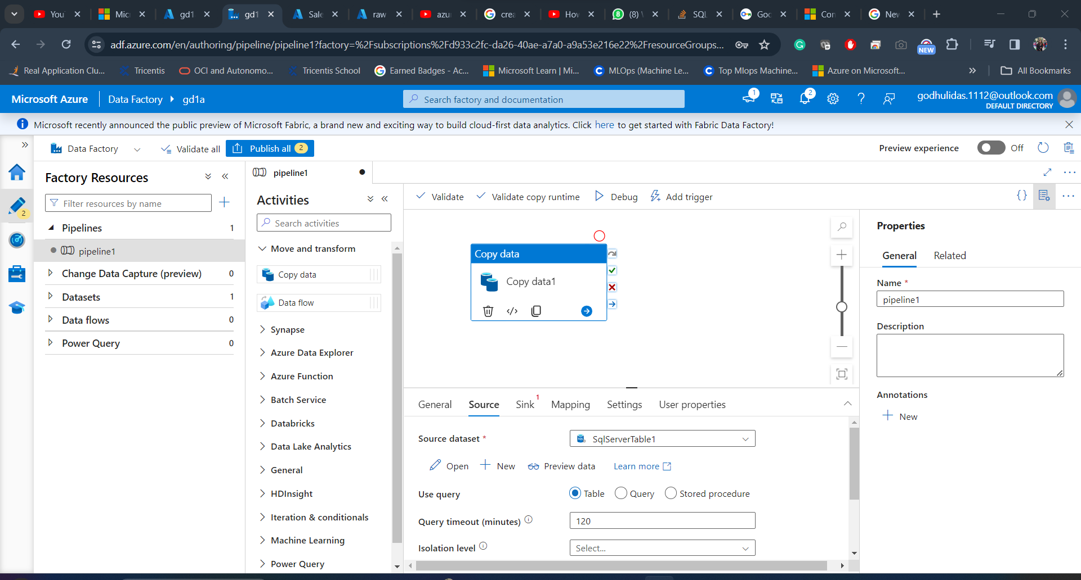

Click on Preview data

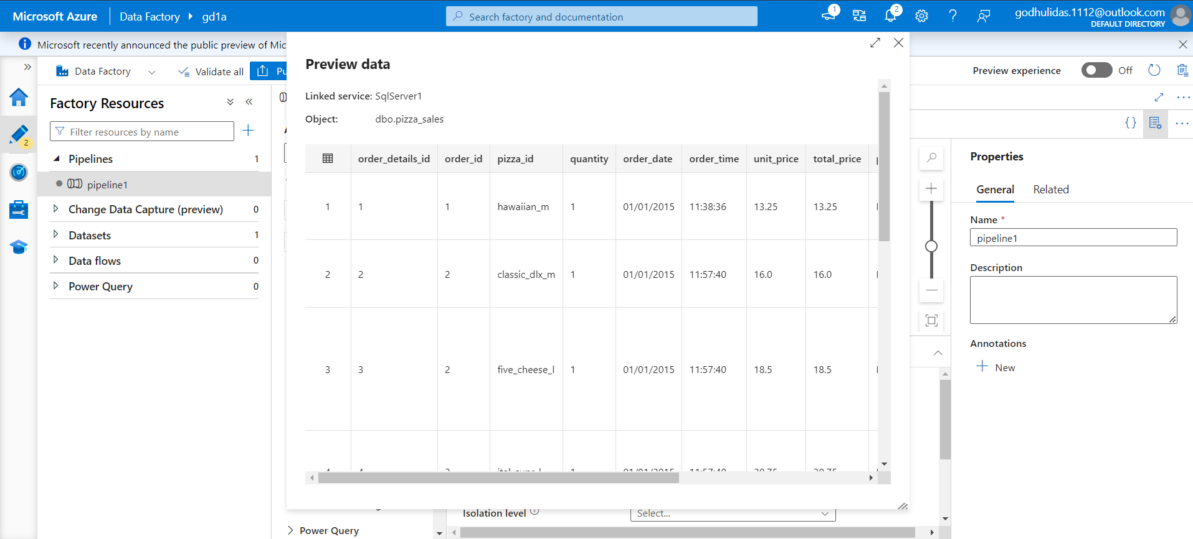

From Sink> New

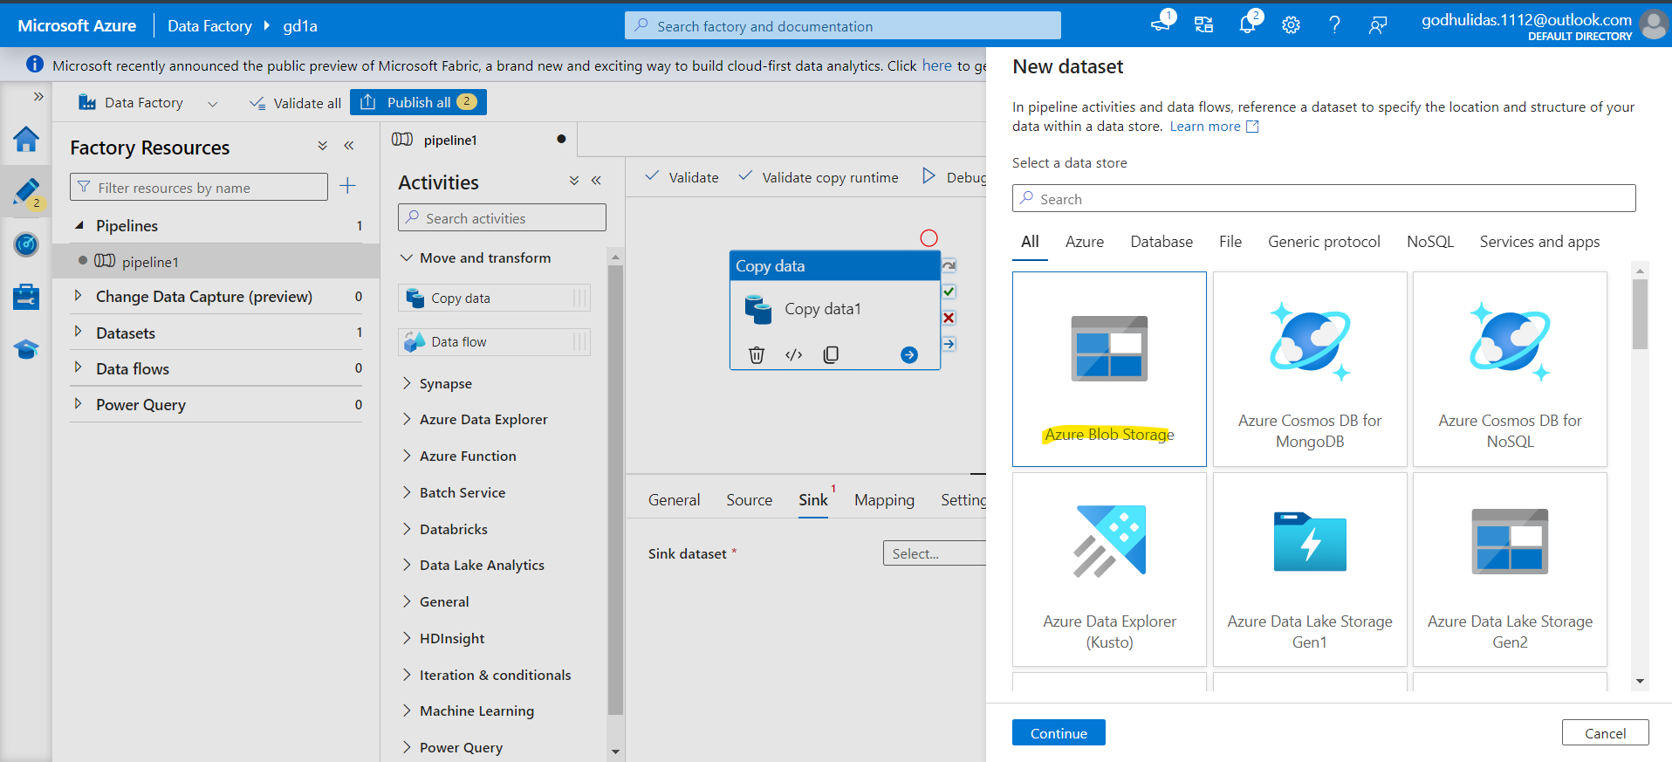 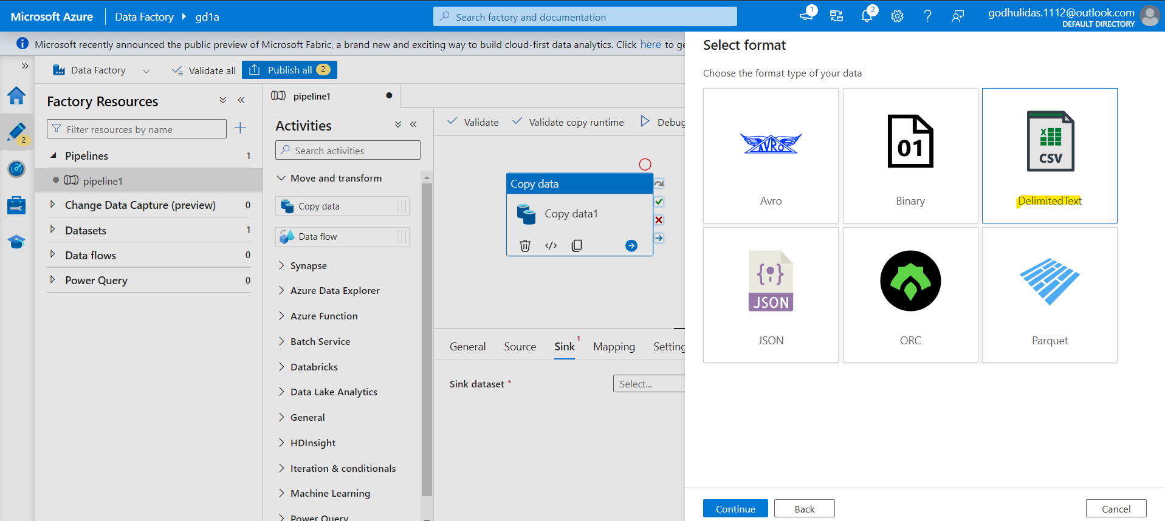

Click Continue.

Click on + New Linked service.

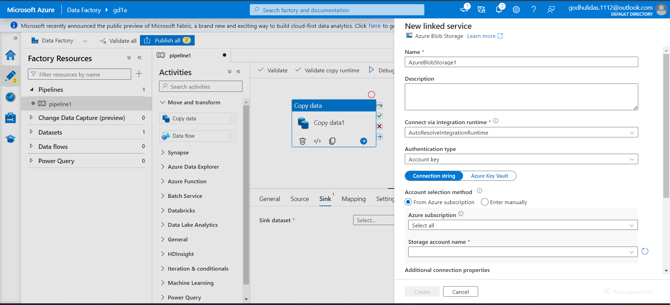

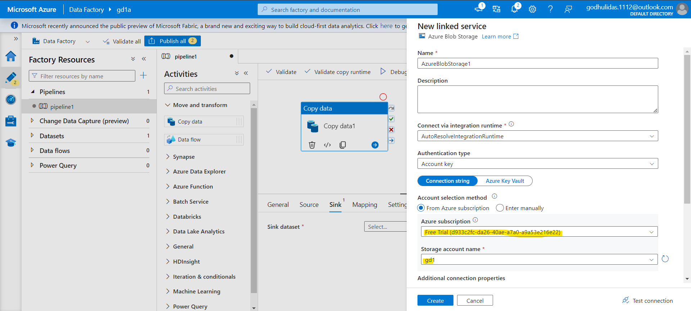

Click Create

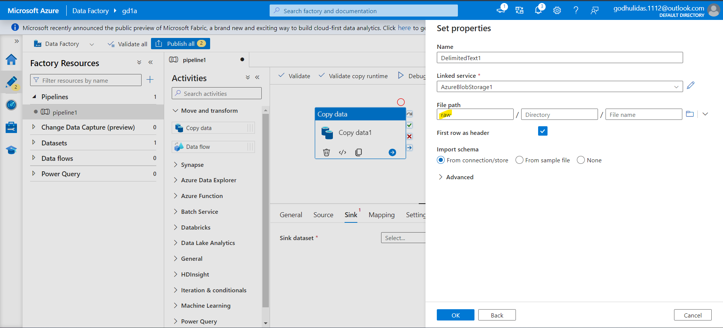

Source Sink both ready

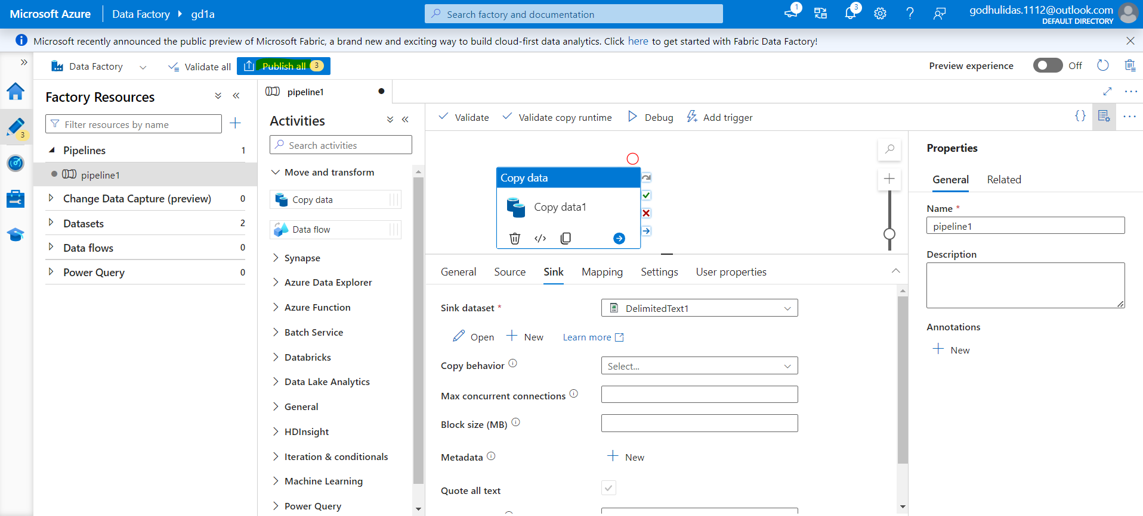 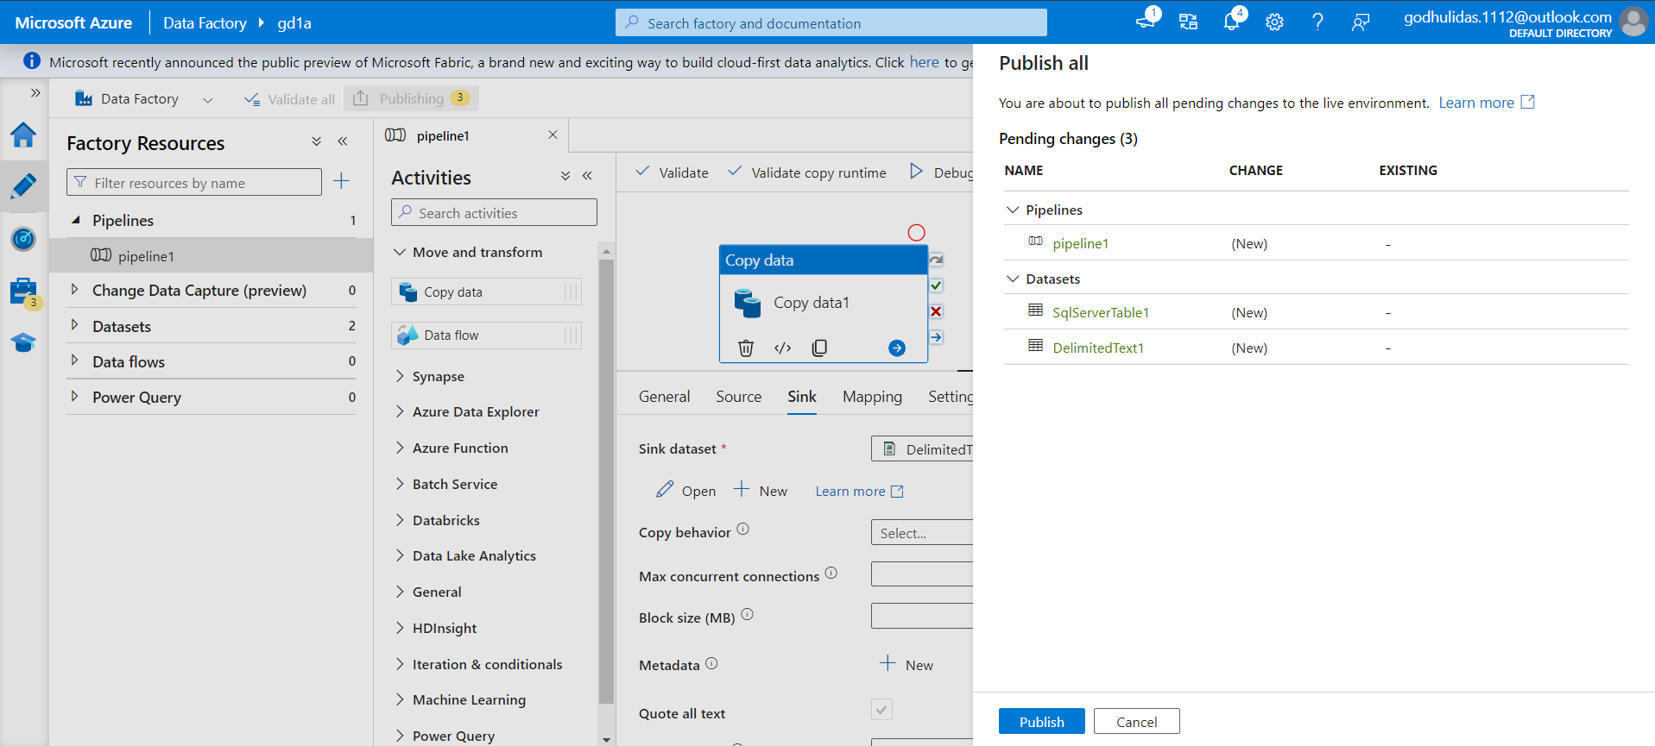

Click on Publish

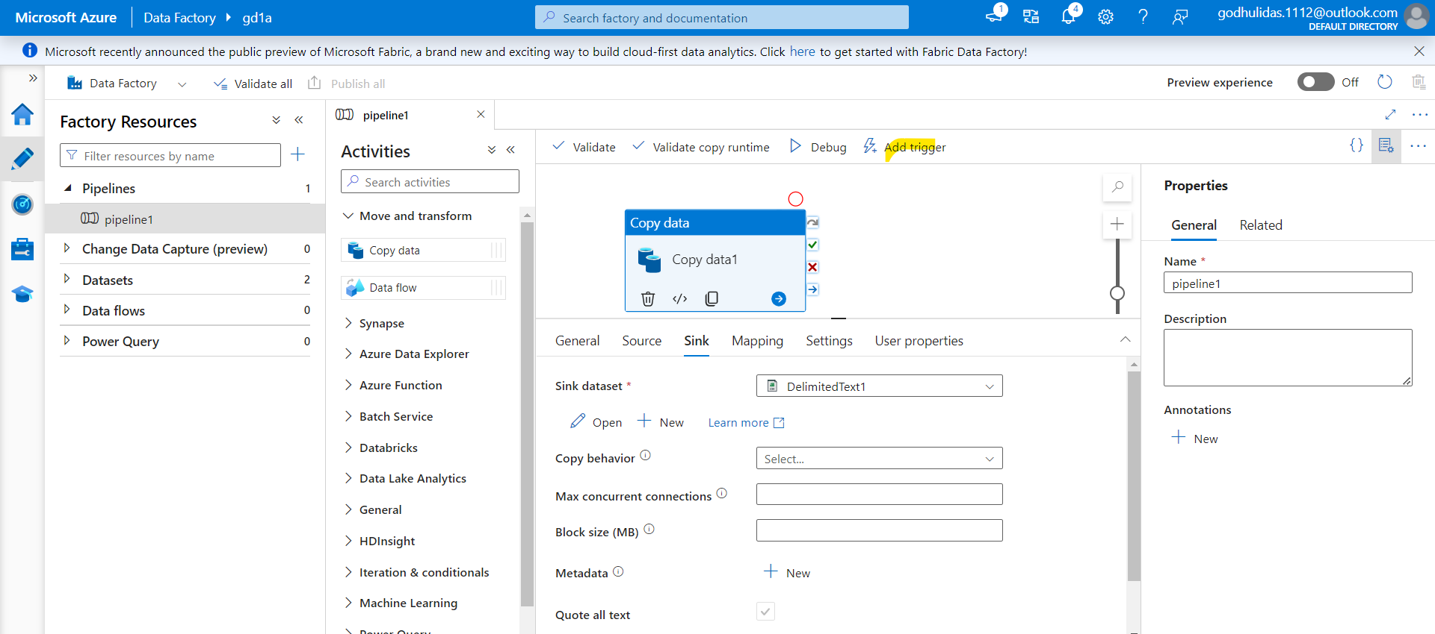

Click on Add Trigger>Trigger Now

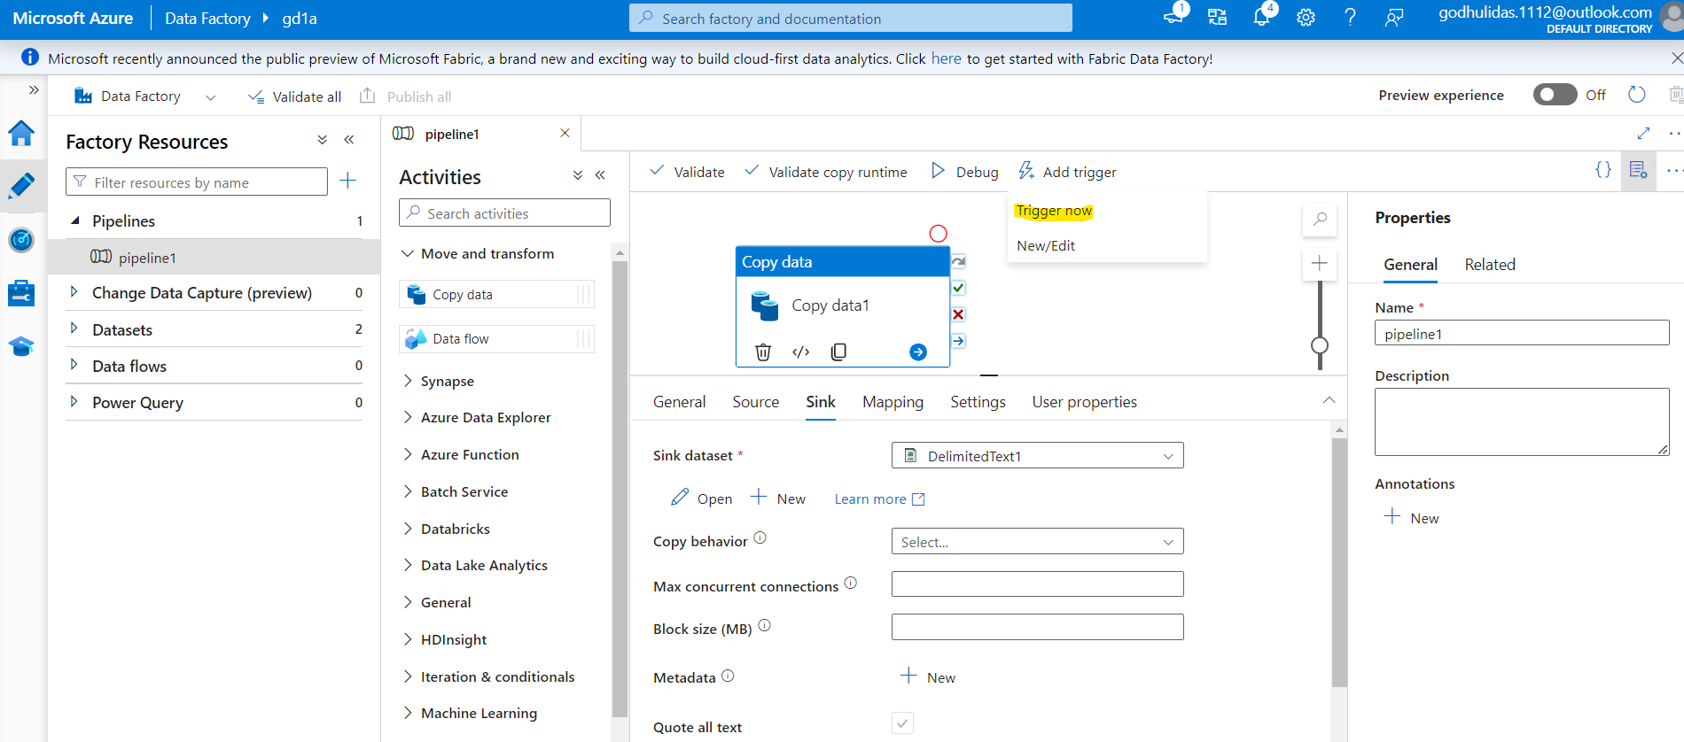

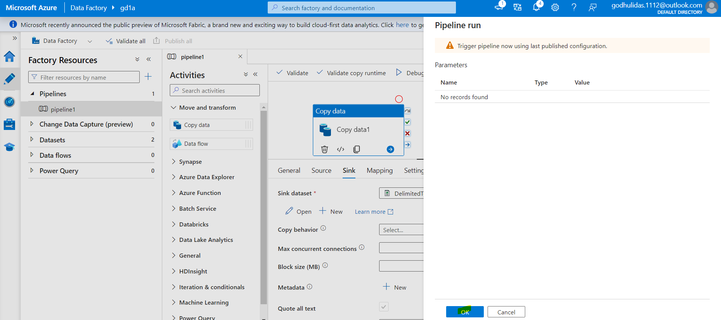

Go to Monitor from the left pane

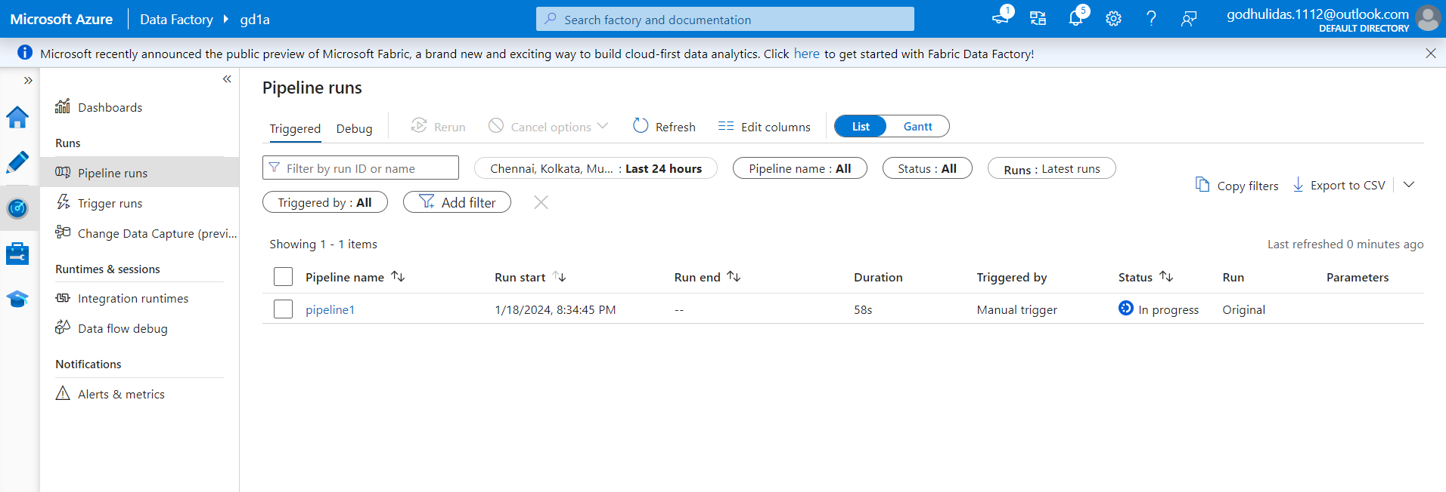

Once pipeline is completed,

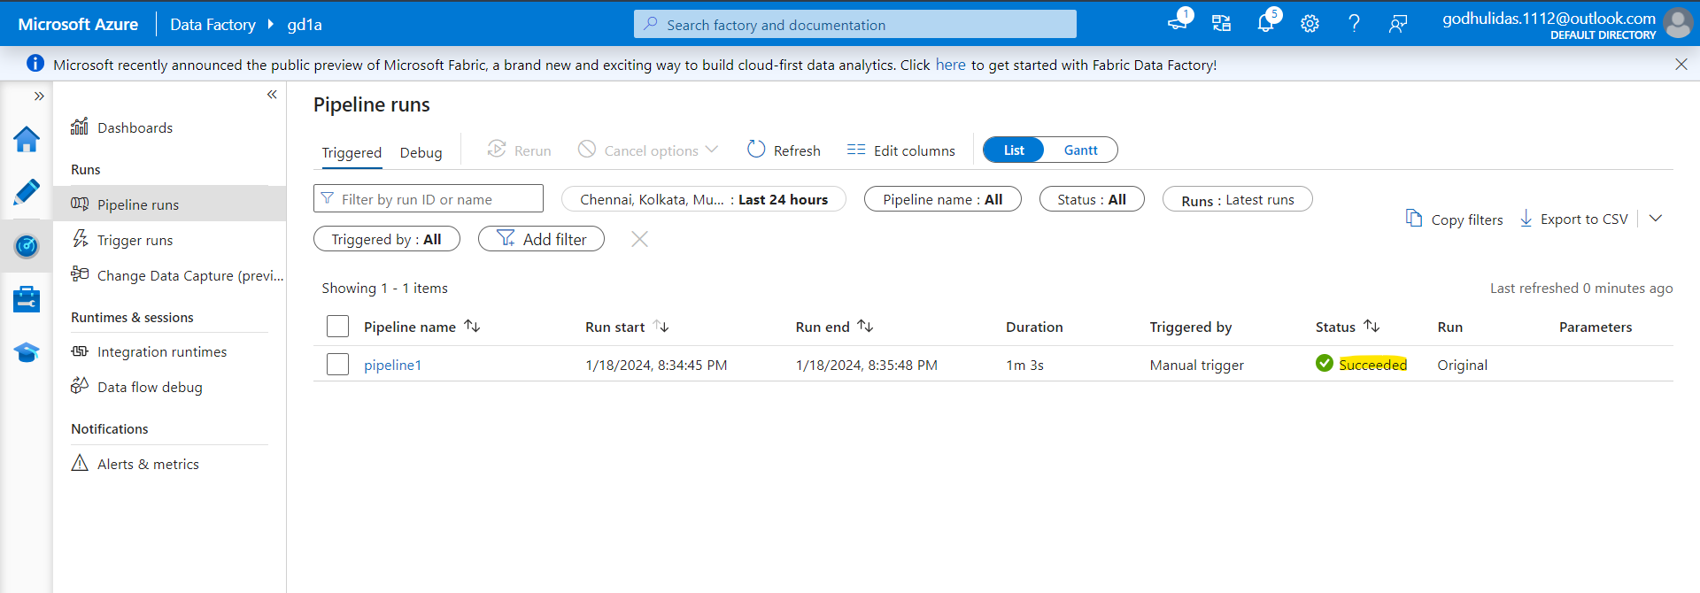

Go to the Azure storage account

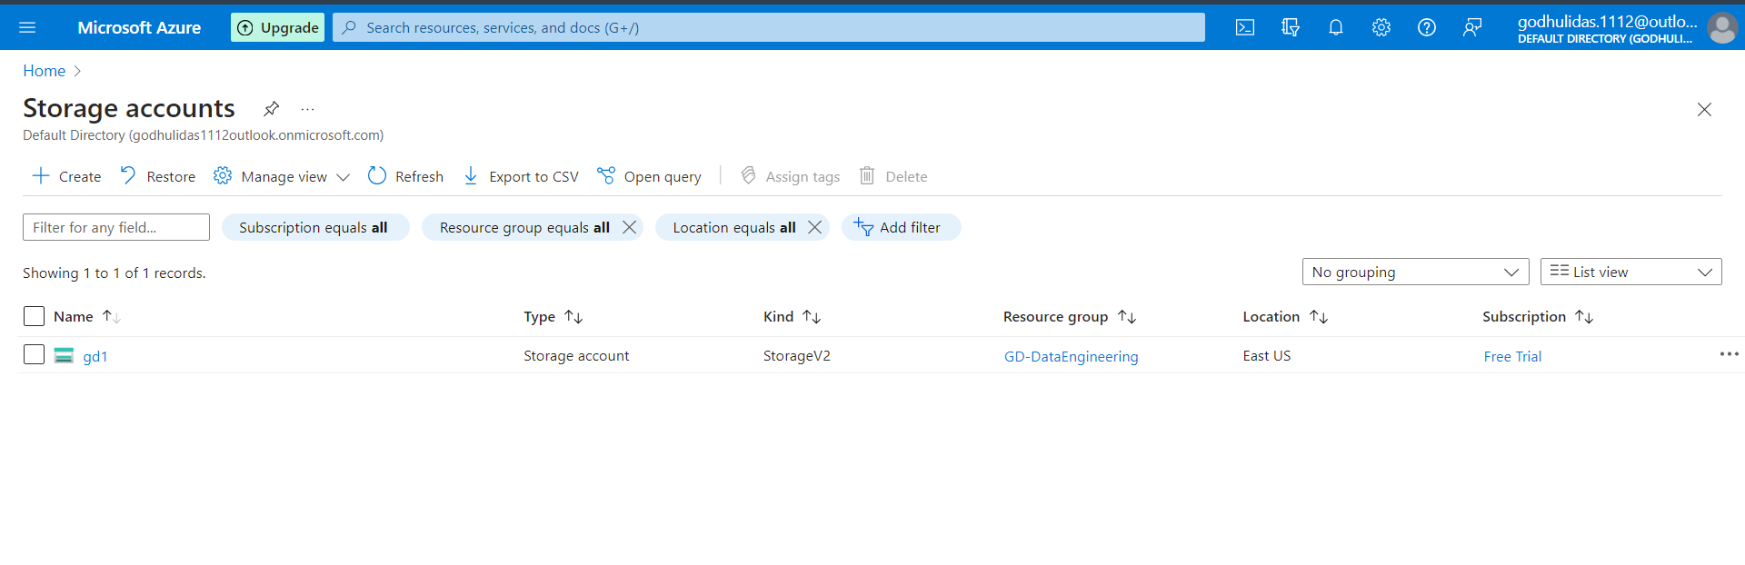

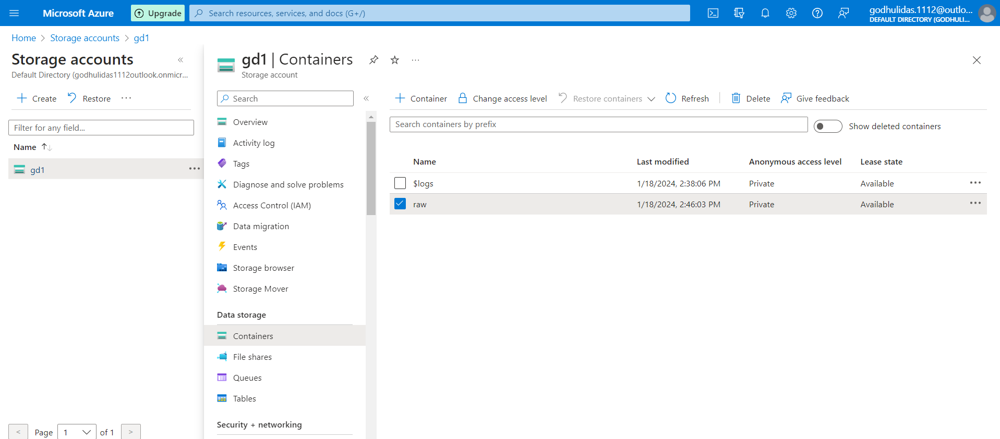

Inside Raw container

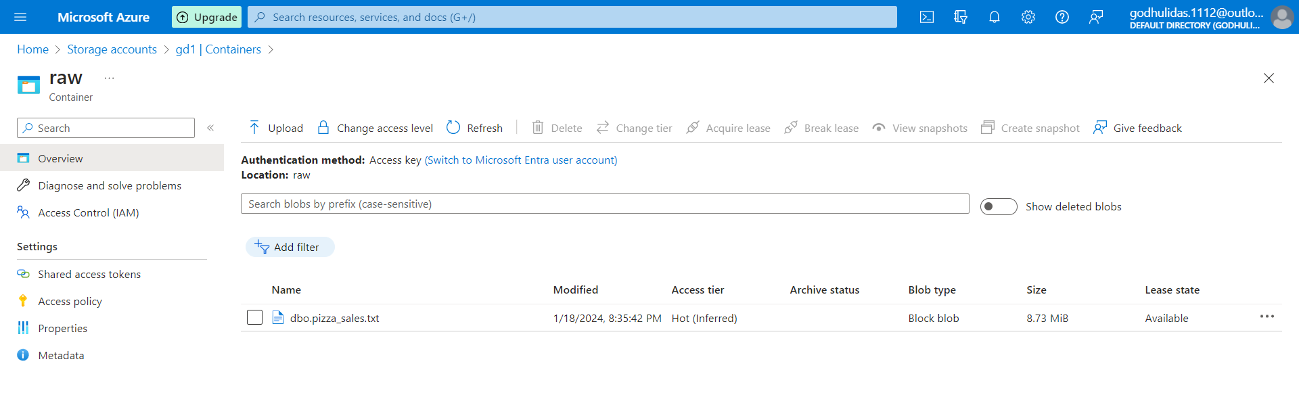

**Now connect with databricks community account**

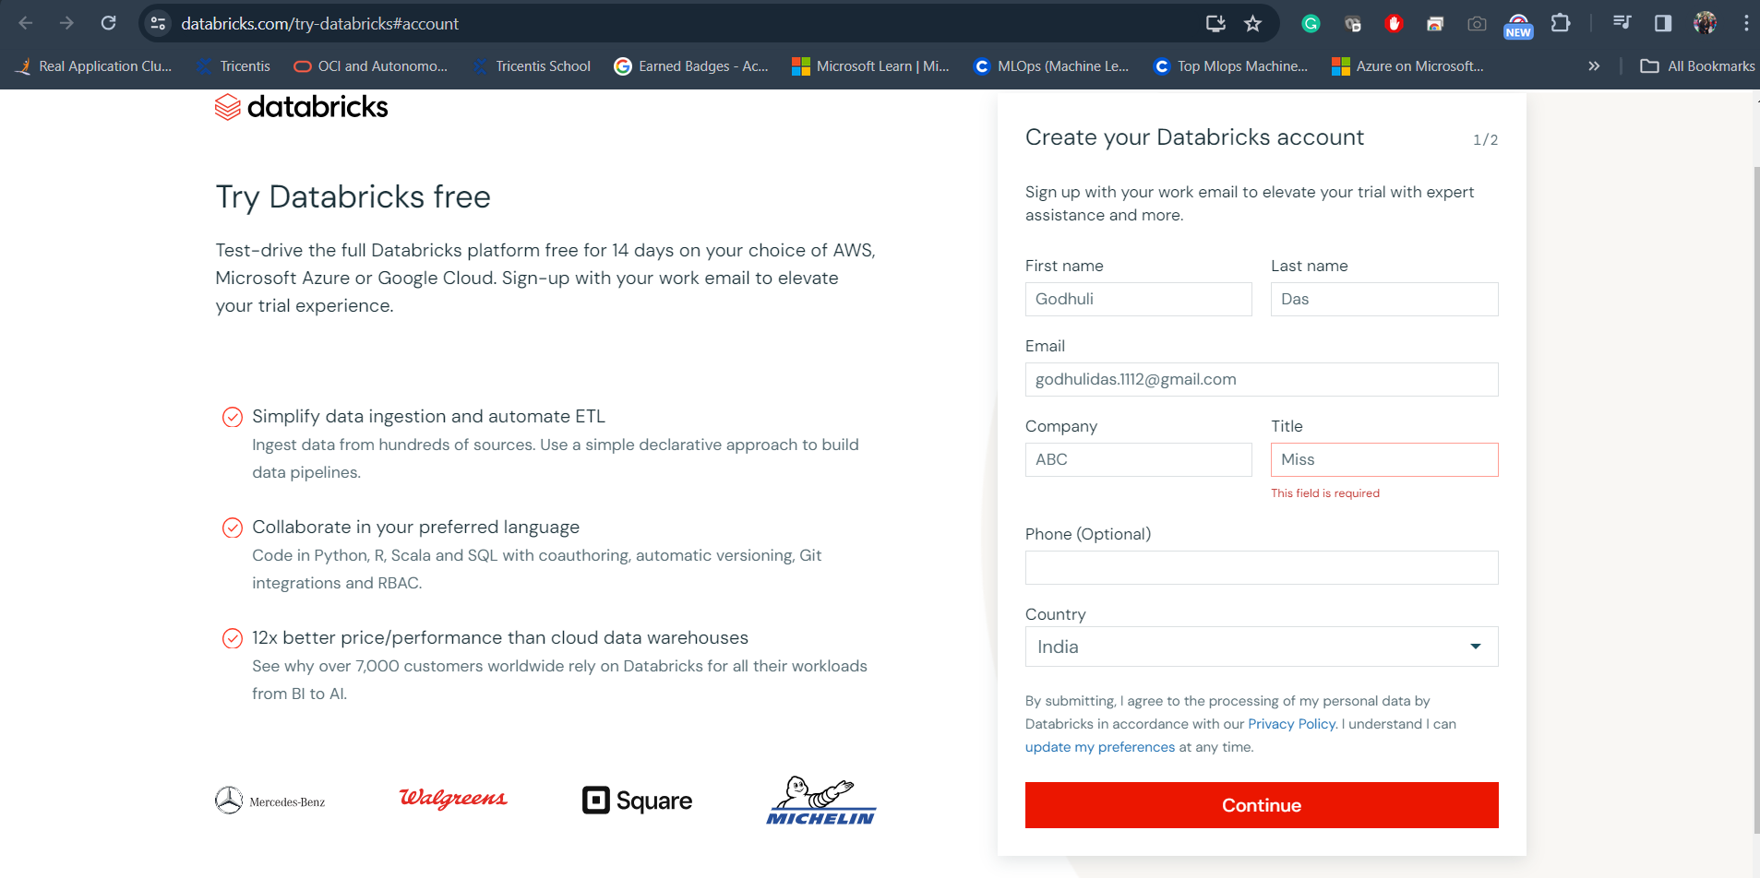

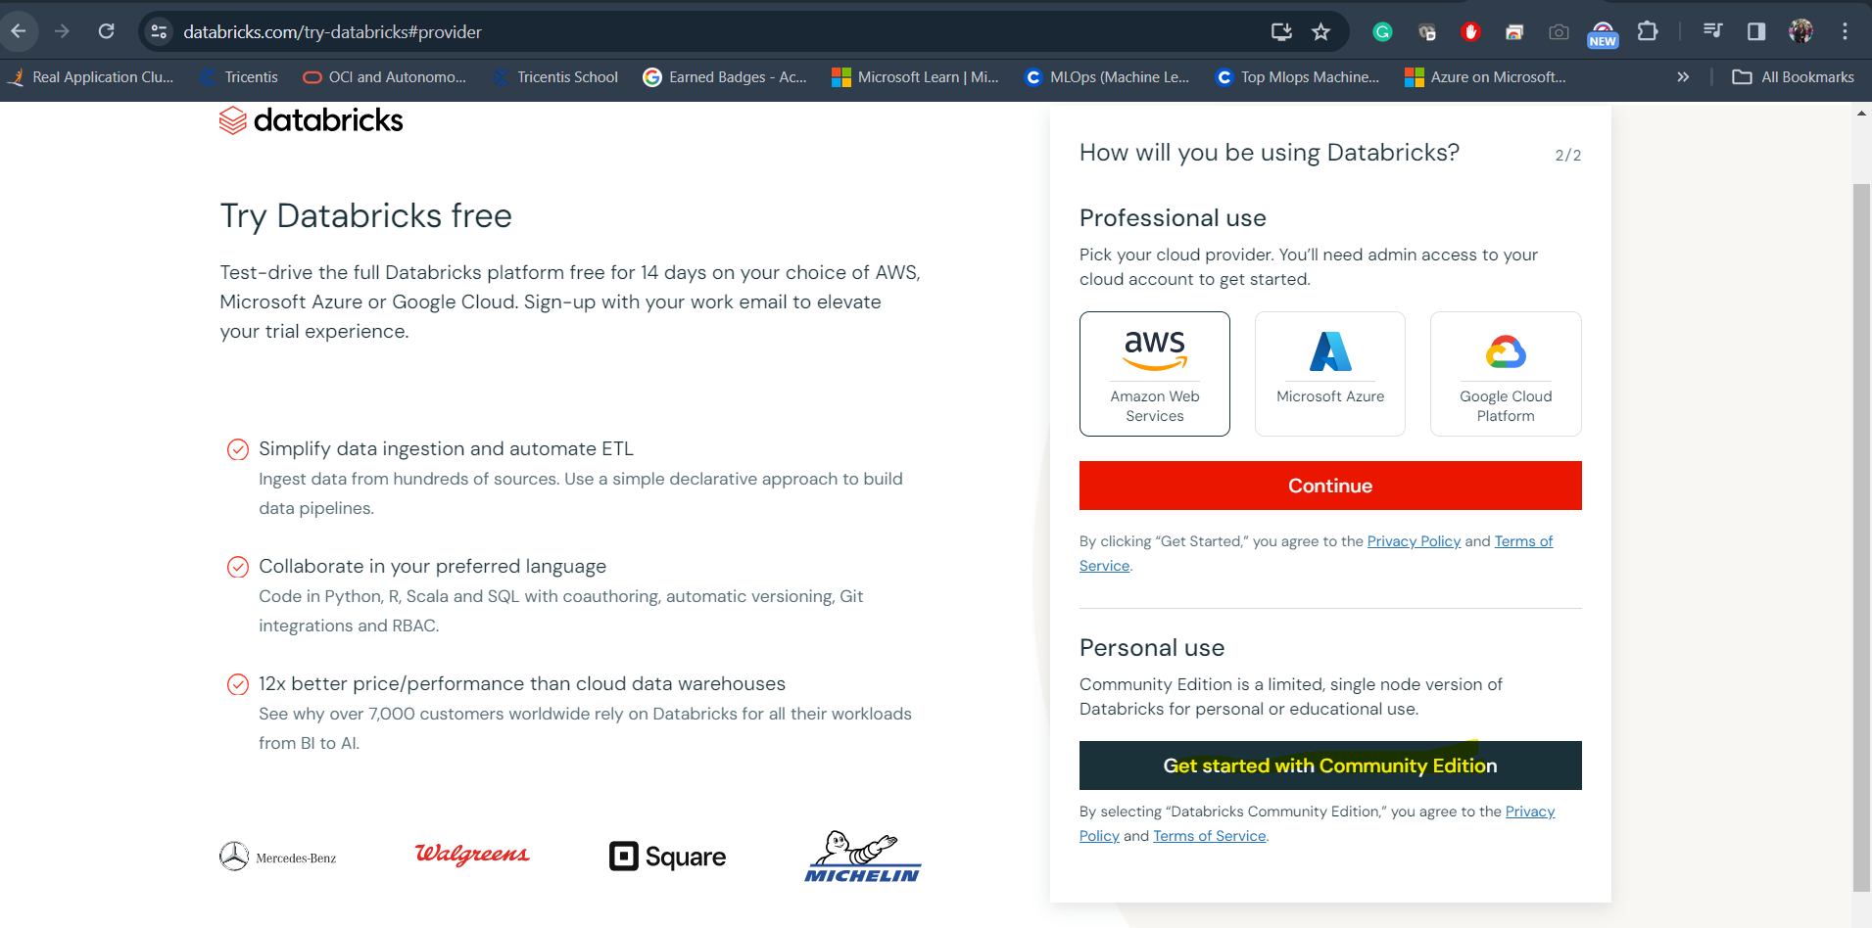

Click Get started with community edition

Mail- godhulidas.1112@gmail.com

Password – Purposeoflife@111230

Login at --🡪https://community.cloud.databricks.com/?o=3511620967284394

Click on Compute from left side pane

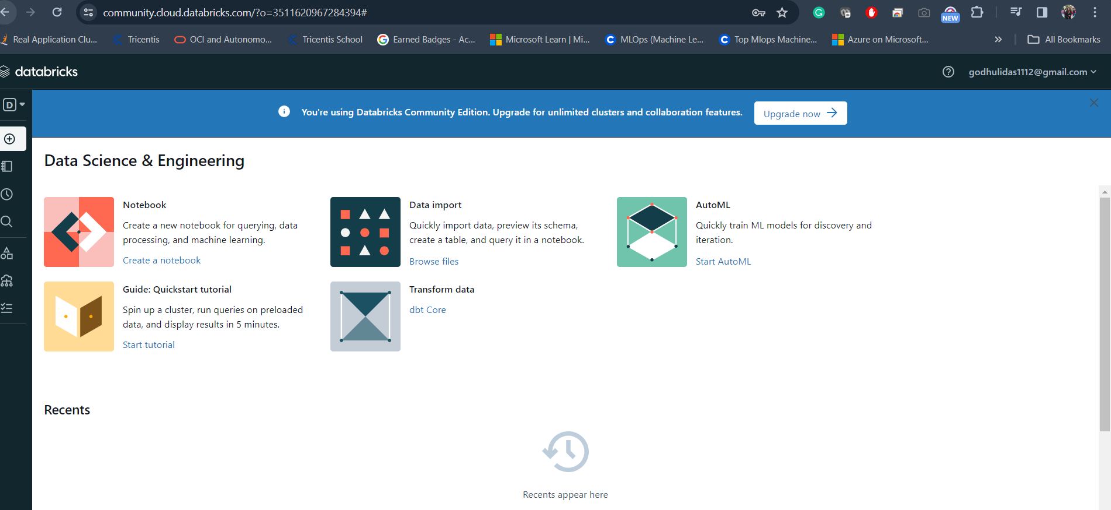

Click on Compute>Create Compute>

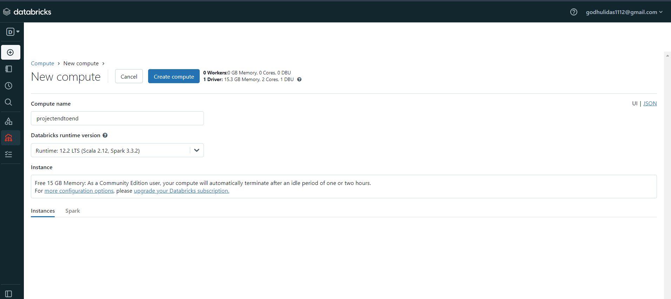

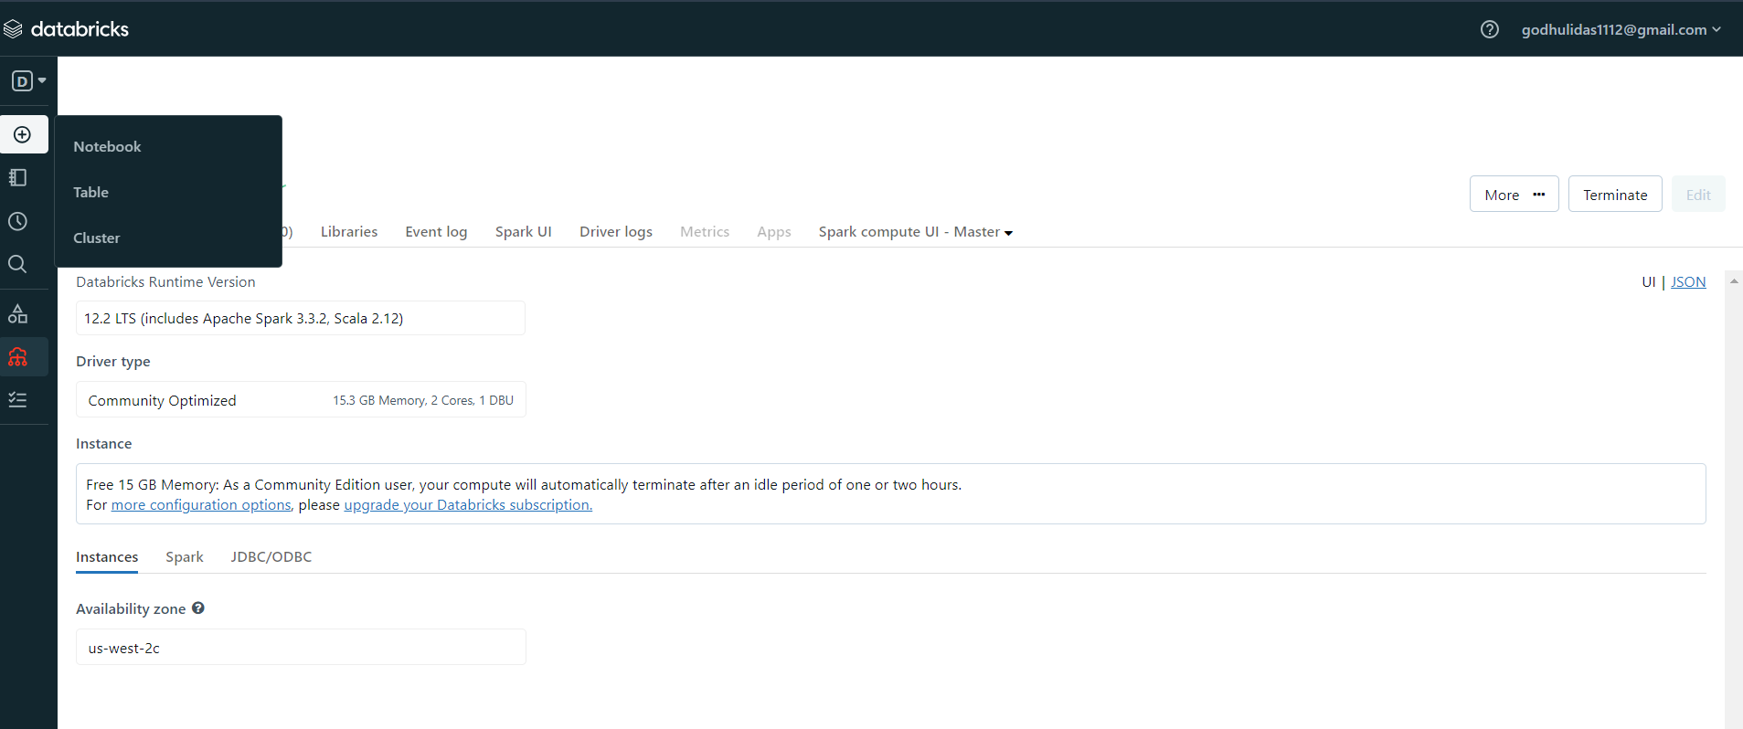

Click on Create > Notebook

Due to 60 mins of inactivity previous cluster terminated so new cluster is cloned and then the notebook I tried to run in cloned cluster.

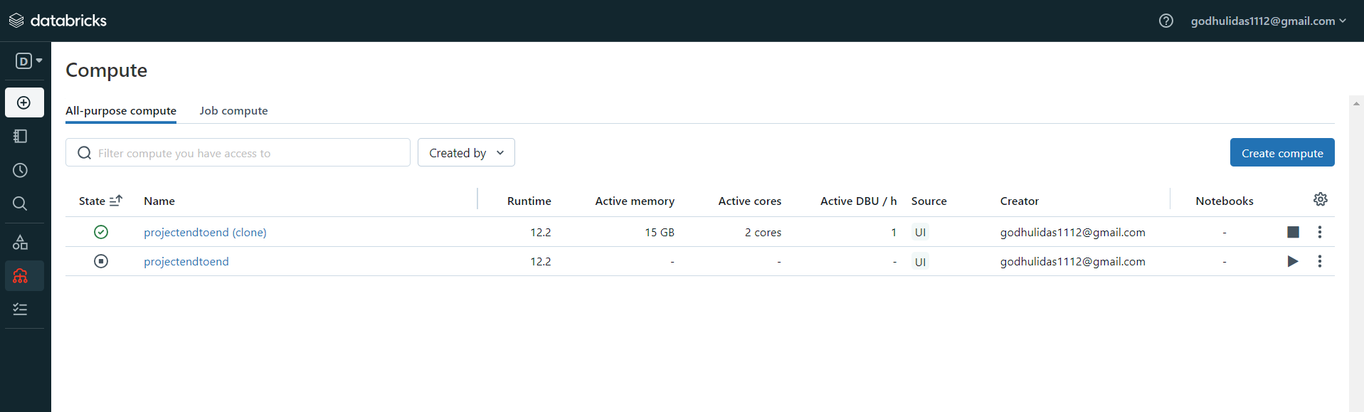

The previous terminated cluster is deleted.

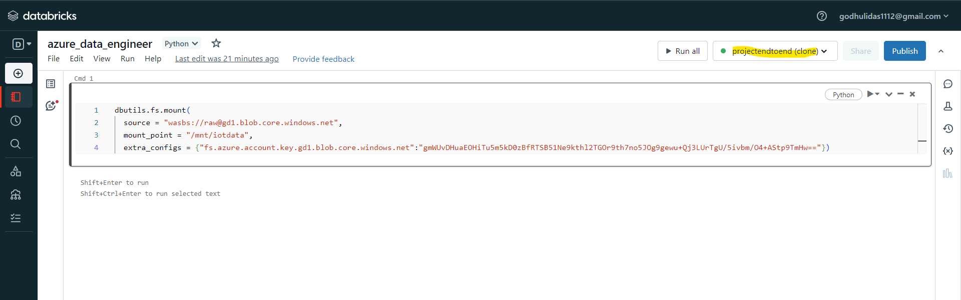

Python notebook created at Databricks community edition



The data from SQL server is manipulated in Databricks and then compressed and downloaded to create KPI s in Power BI .

**Power BI Reporting**

In real time, connection is established directly from Databricks to Power BI but for practice purpose the “export” csv is downloaded in local and then imported in Power BI to create KPIs and dashboard for sales analysis.

